**Complex Number-Determinant Identity Case Study**

**This document contains examples accompanying the paper "** Geometric Theorem Proofs Using Complex Number–Determinant Identities **." The solutions are all one-line proofs generated using the complex number-determinant method. Many of these solutions are worth exploring further, so please explore them.**

**Example 1:** As shown in Fig.1, construct equilateral triangles △*CBX*, △*YAC*, and △*AZB* externally on the sides of △*ABC*. Let points *R*, *S*, and *T* be the centroids of △*CBX*, △*YAC*, and △*AZB*, respectively. Prove that △*RST* is an equilateral triangle. (Napoleon’s Theorem)

△*CBX* ∼ △*ABZ*：；

△*YAC* ∼ △*ABZ*：；

△*STR*∼ △*ABZ*：；

We present the detailed solution process for this problem. First, we define the determinant function xs. Then, we express the problem's conditions and conclusions in the form of a determinant identity. Next, we solve for the values of parameters **k1** and **k2** that make the expression hold identically for variables *A,B,C,X,Y,Z*. Finally, we output the determinant identity to complete the proof.

The key Mathematica code is as follows:

*xs[a_,b_,c_ ,d_,e_,f_]:=Det[{{a,b,c},{d,e,f},{1,1,1}}]//Factor*

*SolveAlways[xs[(C+A+Y)/3,(A+B+Z)/3,(B+C+X)/3,A,Z,B]+****k1*** *xs[C,B,X,A,Z,B]+****k2*** *xs[Y,A,C, A,Z,B] ==0,{A,B,C,X,Y,Z}]*

The computer returns the result:*{{****k1->-(1/3),k2->-(1/3)****}}*

**Proof:**  
.

Traditional geometric proofs proceed through deductive reasoning—deriving the conclusion step-by-step from the given conditions, often resulting in lengthy arguments. In contrast, the identity-based proof relies on a single determinant identity derived from the definition of similarity, involving minimal computation and offering a highly concise solution. The reasoning logic is as follows:

Given: △*ABZ*, △*BCX*, and △*CAY* are equilateral triangles ⇒ the two determinants on the right-hand side of the identity are zero (by applying Property 1 to similarities such as △*CBX* ∼ △*ABZ*).  
The identity holds ⇒ the left-hand side determinant is zero ⇒ △*STR* ∼ △*AZB* (by applying Property 1) ⇒ △*STR* is an equilateral triangle. In many cases, verifying the validity of the identity does not require fully expanding each determinant; simple addition or subtraction based on determinant properties often suffices. This illustrates the difference between the determinant identity method and traditional geometric proofs—it significantly reduces computational effort and is easier to execute manually.

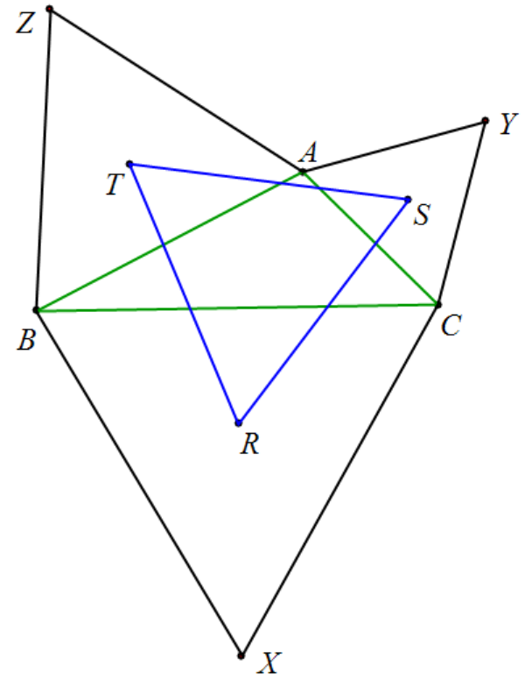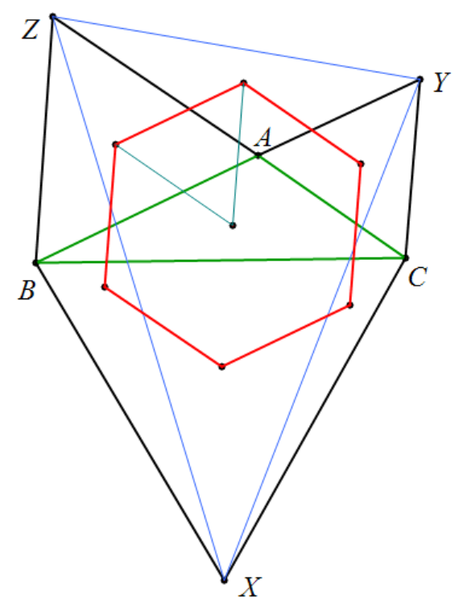

Figure 1 Figure 2

the identity : As shown in Figure 2, the centroids of △AYZ, △BXZ, and △CYX form an equilateral triangle.

the identity : The centroids of △ABC, △AYZ, and △ABZ form an equilateral triangle. Furthermore, the centroids of △AYZ, △ABZ, △BXZ, △BCX, △CYX, and △CYA form a regular hexagon, the center of which is the centroid of △ABC.



**Example 1: Draw** equilateral triangles △CBX, △YAC, and △AZB outside △ABC. R, S, and T are the centroids of △CBX, △YAC, and △AZB respectively. Prove that the centroid of △ABC coincides with the centroid of △RST.

 .

According to the identity, . And △SAC is an isosceles triangle with a vertex angle of 1 20 °, so the only possibility is , Only when it degenerates into a point can it be regarded as an isosceles triangle with a vertex angle of 120 °.

**Example 1:** Construct equilateral triangles △CBX, △YAC, and △AZB outside △ABC. Take point D on CZ, with 3CD = CZ , take point E on BY, with 3BE = BY, take point F on AX, with 3AF = AX . Prove that △DEF is an equilateral triangle.

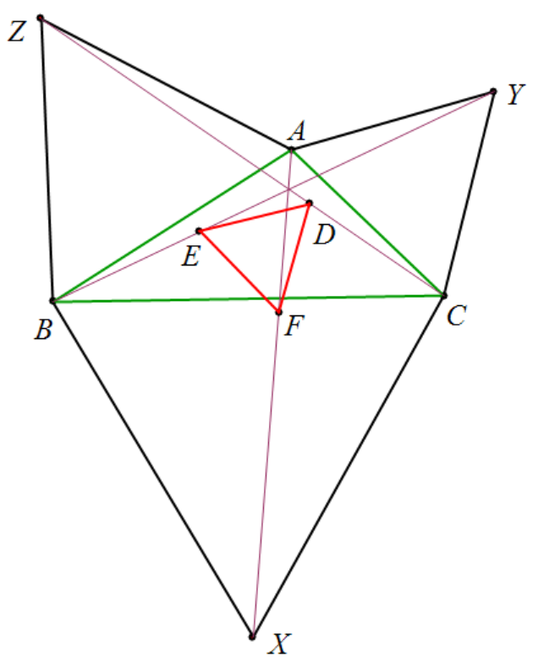

prove: .

Note: The three-division point can be further expanded to a more general proportional point:

.

**Example 1: Draw** equilateral triangles △YAC and △AZB outside △ABC. D and E are the midpoints of CZ and BY respectively. Prove that △ADE is an equilateral triangle.

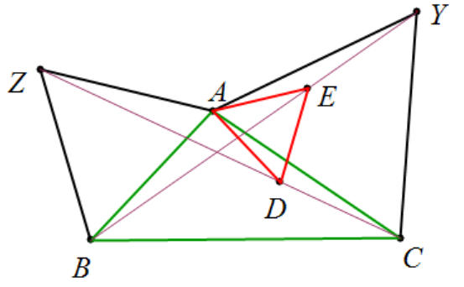

**.**

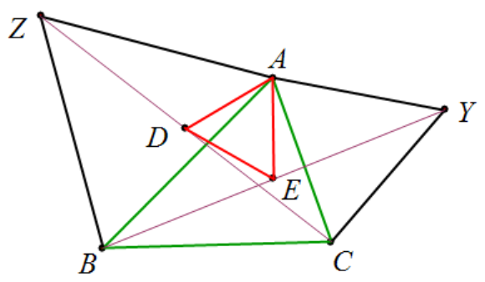

**Example 1: Draw** equilateral triangles △YAC and △AZB outside △ABC. D and E are the midpoints of CZ and BY respectively. Prove that △ADE is an equilateral triangle.

when , .

when , .

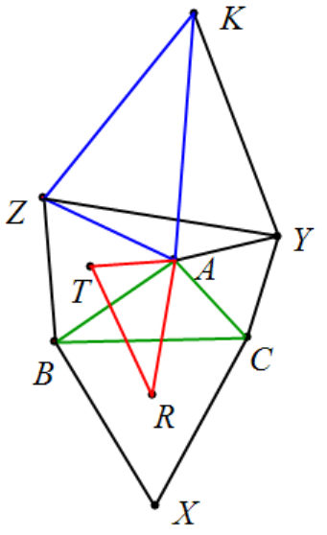

**Example 1: Draw** equilateral triangles △CBX, △YAC, and △AZB outside △ABC. R and T are the centroids of △BCX and △AZB respectively. K and X are symmetric about A. Then △ZYK∽△AZB, and △RAT∽△KZA.

,



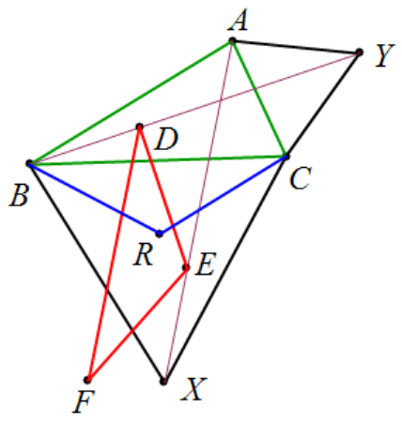

**Example 1: Draw** equilateral triangles △CBX and △YAC outside △ABC. R is the centroid of △BCX. Let D be the point that divides BY into three equal parts, E is the point that divides XA into three equal parts, and F and C are symmetric about E. Then △RCB∽△EDF.

.

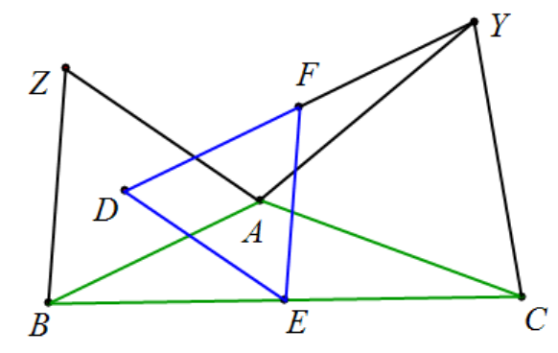

**Example 1: Draw** equilateral triangles △YAC and △AZB outside △ABC. D is the centroid of △AZB, E is the midpoint of BC, and F is the midpoint of DY. Then △DEF is an equilateral triangle.

.

**Example 1:** As shown in the figure, the centroid of △ABC is S, and an equilateral △CDE is constructed through point C. △ FEA and △ GBE are triangles with an angle of 30 ° - 30 ° -120 ° . Prove that △SFG is a triangle with an angle of 30 ° - 30 ° -120 °.

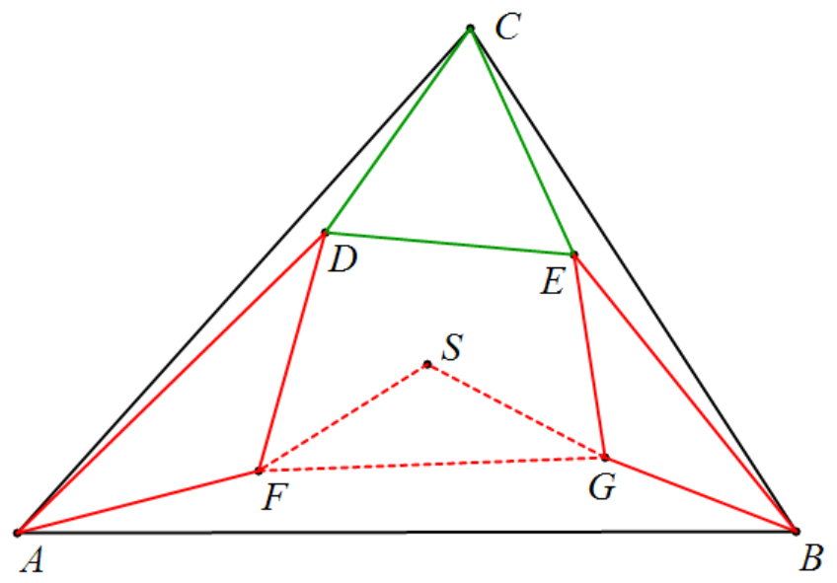



.

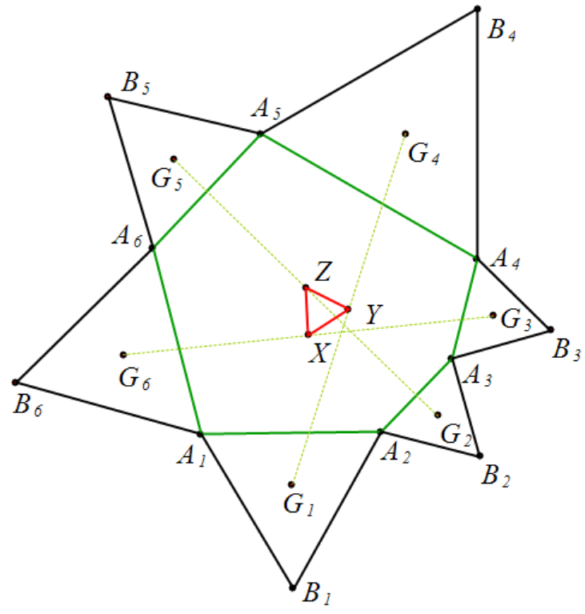

**Example 1:** Draw equilateral triangles outward from each side of the hexagon . , , , , , , , , , , , are the centroids of , , , , , respectively . X, Y, and Z are the midpoints of , , , respectively . Prove that △XYZ is an equilateral triangle.

Proof: Let △ABC be an equilateral triangle,



.

**Example 1:** For hexagon ABCDEF, construct equilateral triangles , , and . Let be the centroids of , , , , , , , , , respectively . Then , , , are all equilateral triangles .

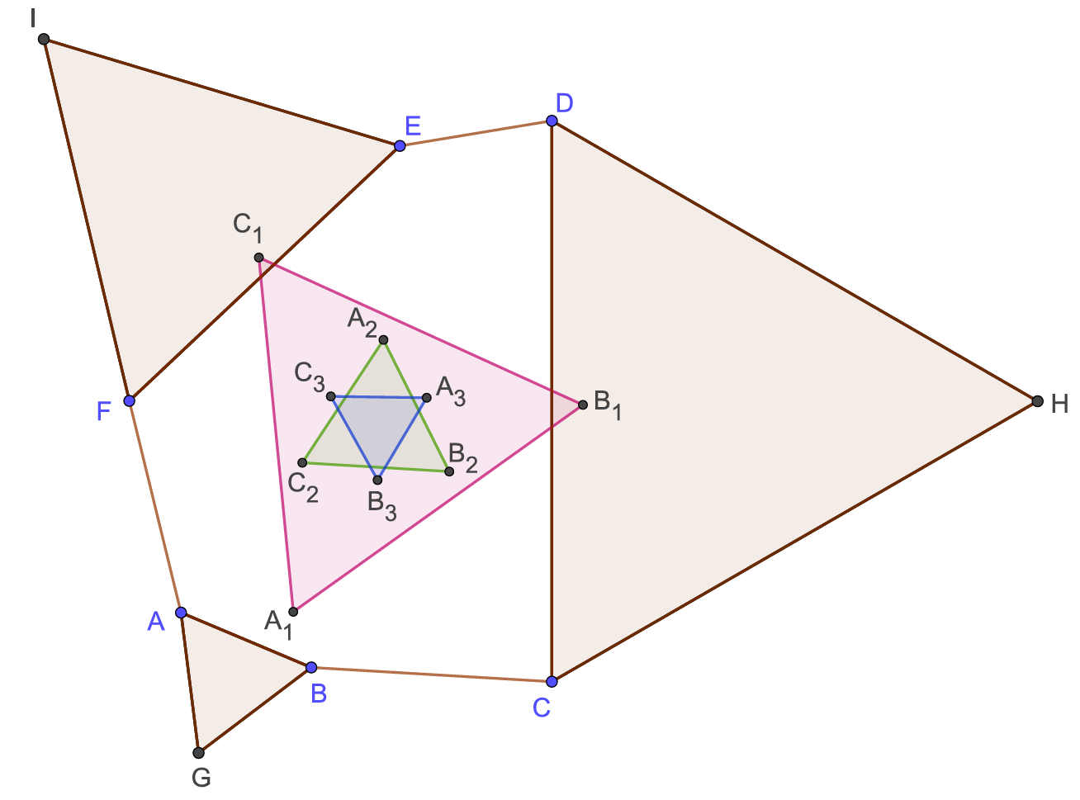

Proof: Let △XYZ be an equilateral triangle,

,

,

.

Note 1: When B and C coincide, D and E coincide, and F and A coincide, it is an equilateral triangle, which is Napoleon's theorem.

Explanation 2 : Equilaterals , , , so , after rotation, there are , etc., for a total of nine permutations, resulting in nine similar propositions. The above only lists three examples. Traditional geometric reasoning requires strong geometric intuition to discover and prove such problems. However, the algorithm in this paper can generate them in batches without duplication or omission.

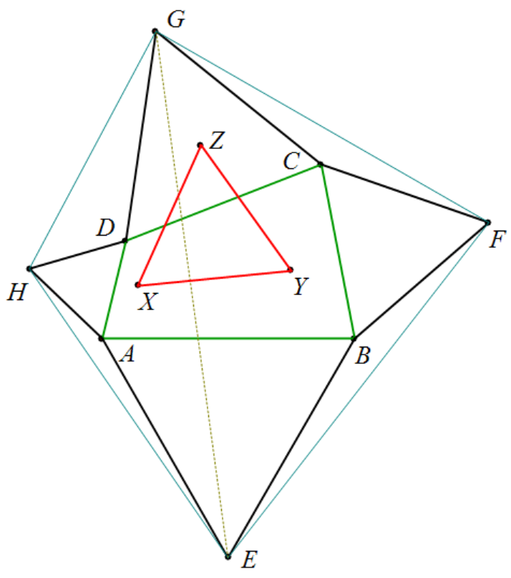

**Example 1:** Construct equilateral triangles ABE, BCF, CDG, and DAH outside quadrilateral ABCD. X, Y, and Z are the centroids of △EGH, △EFG, and △CDG respectively. Prove that △XYZ is an equilateral triangle.

prove: .

Explanation: Based on the identity, we find that △CDG is an equilateral triangle, which is a superfluous condition. This is due to the symmetrical thinking of human experts when formulating problems. Since superfluous conditions do not affect the correctness of the conclusion, they are difficult to spot. However, using the identity method, it is easy to eliminate them.

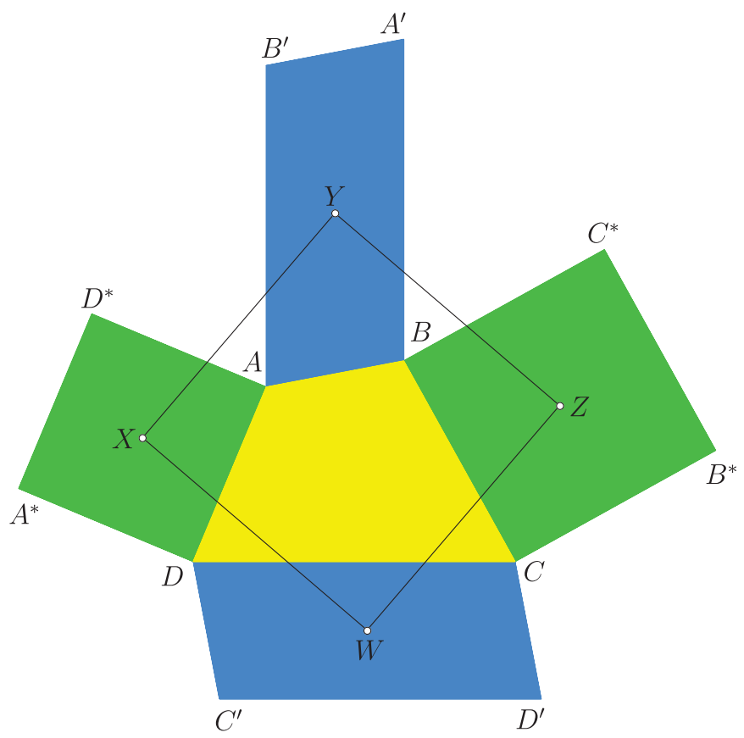

**Example 1:** Convex quadrilateral ABCD satisfies , . Construct squares and outside sides AD and BC, respectively ; construct parallelograms ABA'B' and CDC'D' outside sides AB and CD, respectively, perpendicular to and equal in length to CD and perpendicular to and equal in length to AB. Let the centers of the square , parallelogram ABA'B', and the centers of the square and parallelogram CDC'D' be , respectively . Prove that four points form a square.

prove:

.

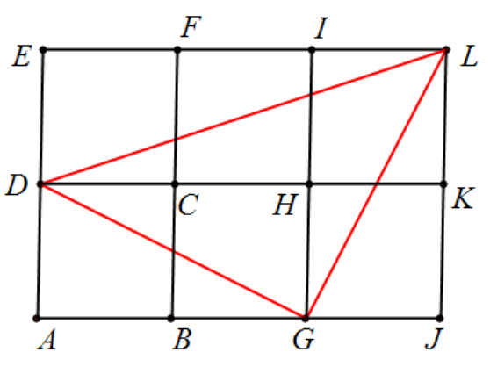

**Example 1 :** As shown in the figure, for square ABCD, extend AB to J so that AJ = 3 AB, and G is the midpoint of BJ. Extend AD to E so that AD = DE. Construct parallelogram AJLE. Prove that △DGL is an isosceles right triangle.

prove: .

**Example 1 :** △ABC and △ADE are both isosceles right triangles. M is the midpoint of EC. Prove that DM=BM and DM⊥BM.

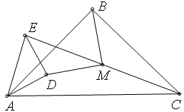

prove: .

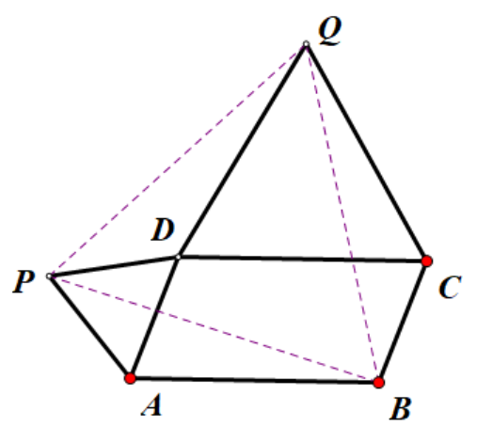

**Example 1 :** For parallelogram ABCD, draw equilateral triangles △ADP and △DCQ. Prove that △PBQ is an equilateral triangle.

Proof: Assume that .

**Example 1:** Squares ABCD, DEFG, FHIJ share vertices D and F. Point K is the midpoint of AJ. Prove that: and .

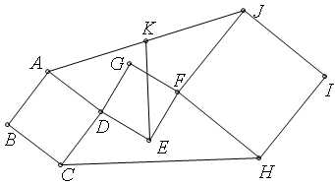

prove: .

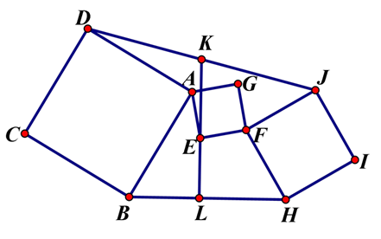

**Example 1:** Given squares , , , with as their midpoints, connect them . Prove that , and .

prove:



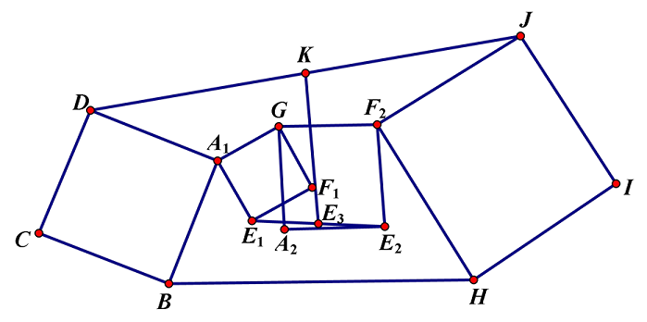

**Example 1:** Given squares , , , , with as midpoints, connect them . Take their midpoints and connect them . Prove that , and .

prove:



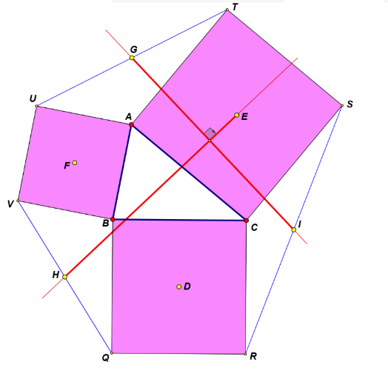

**Example 1:** The centers of the squares CBQR, ACST, and BAUV are D, E, and F respectively, and I, G, and H are the midpoints of RS, TU, and VQ respectively. Prove that: GI = EH and GI ⊥ EH.

Proof: Assume , , make a parallelogram HEGK, ,

.

**Example 1:** With sides AC and CB of △ABC, construct squares ACDE and CBFG respectively. H is the midpoint of EF, and construct parallelogram BACK . Prove that △HAB and △EKF are isosceles right triangles.

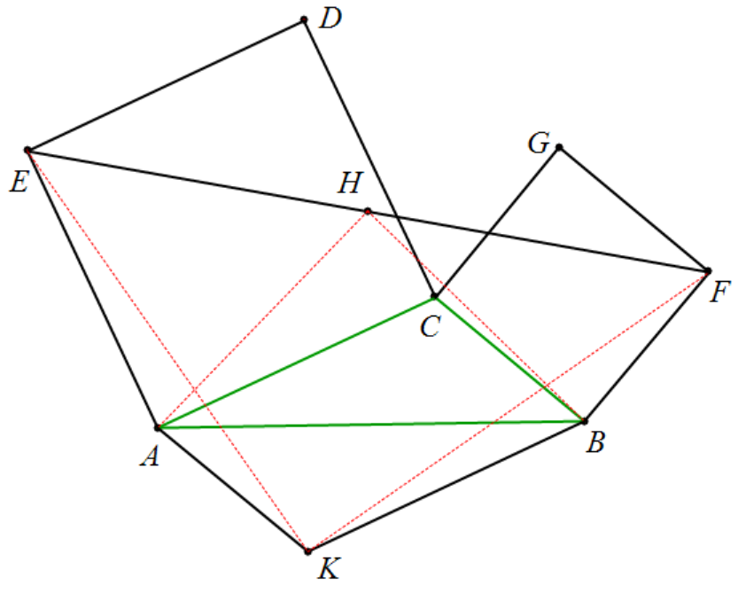

prove: , ,

,

.

**Example 1: Construct squares BADE, ACFG, and HICB outward** from the sides of triangle ABC, and then construct parallelograms HBEJ and CIKF with BE, BH, CF, and CI as adjacent sides. Prove that: triangle JAK is an isosceles right triangle .

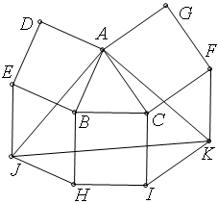

prove: , , ,

.

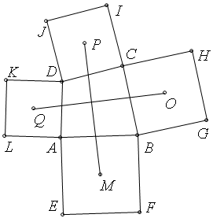

**Example 1:** Construct squares outward from each side of quadrilateral ABCD. Their centers are Q, M, O and P respectively. Prove that and .

prove:

.

This is Aubel **'s** theorem. Even if one side of the quadrilateral is zero length, the statement still holds. The same conclusion holds if we construct a square inwards from each side of quadrilateral ABCD.

**Example 1:** Octagon . Make squares outward from each side with the centers being , , , and connect the midpoints of to form a quadrilateral. Prove that the diagonals of this quadrilateral are equal and perpendicular to each other .

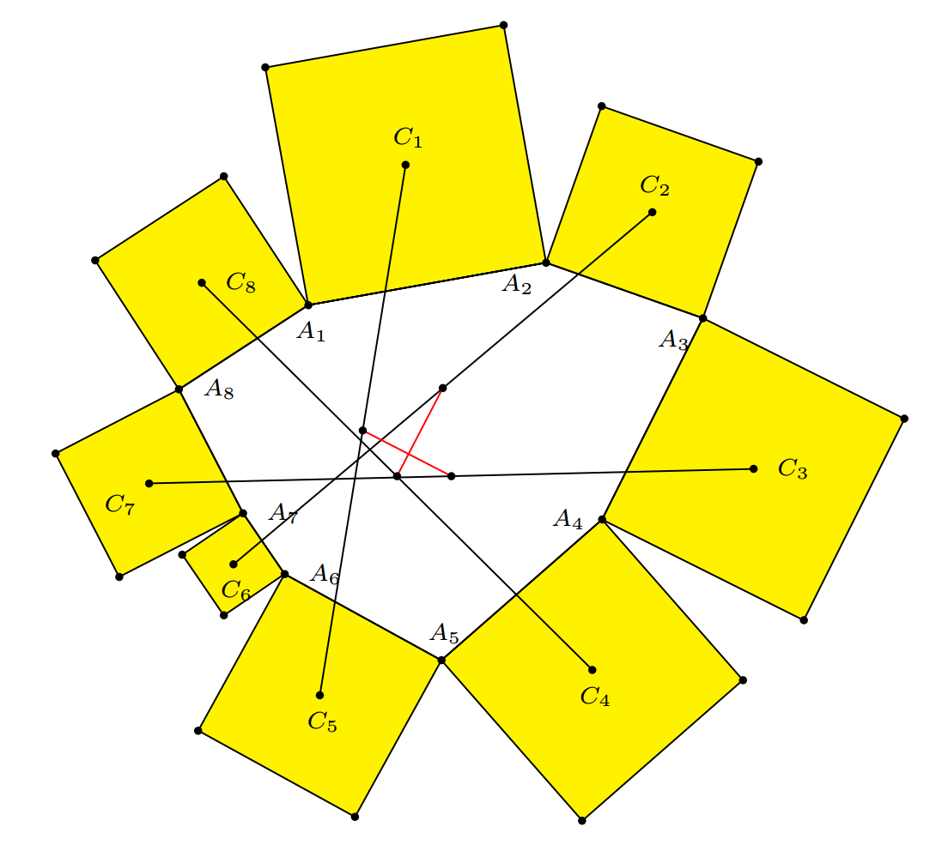

prove:



.

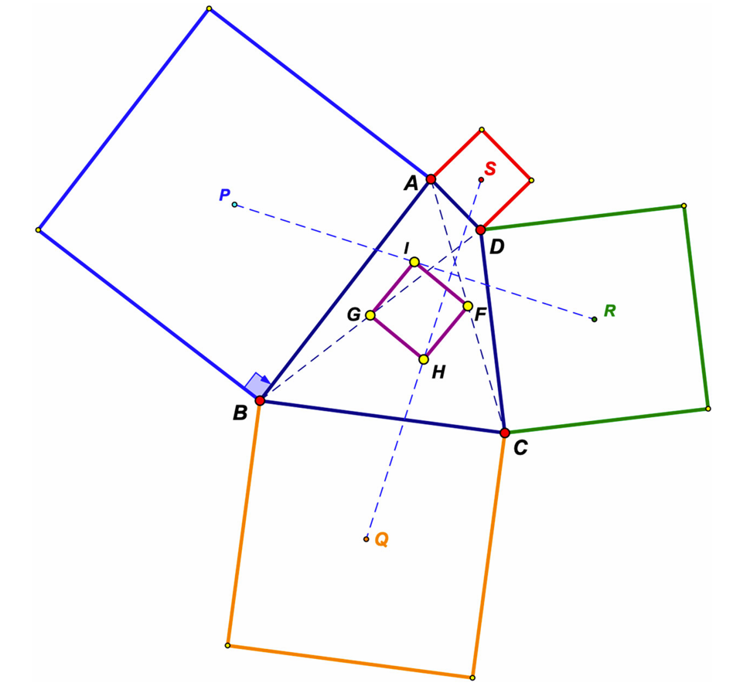

**Example 1:** Construct squares outward from each side of quadrilateral ABCD. Their centers are P, Q, R, and S respectively. F, I, G, and H are the midpoints of AC, BD, PR, and SQ respectively. Prove that quadrilateral IGHF is a square.

prove:



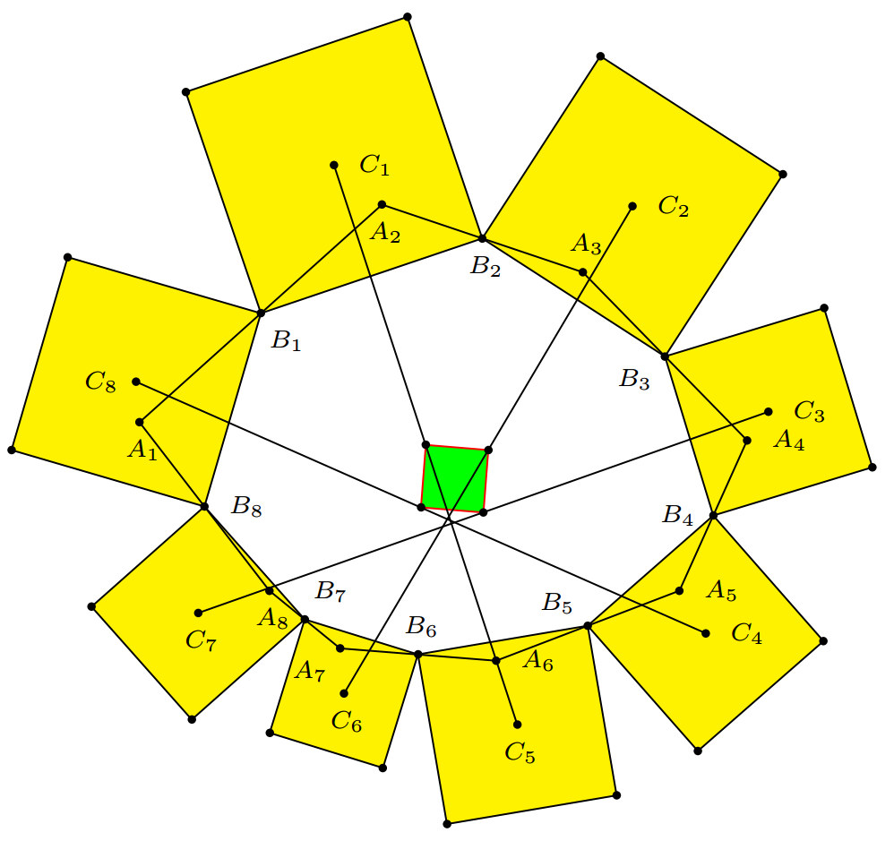

**Example 1:** Octagon . Take the midpoints of each side to form an octagon . Make squares outward from each side with the centers being , , , and connect the midpoints of to form a quadrilateral. Prove that this quadrilateral is a square .

prove:







**Example 1: For a quadrilateral** , draw isosceles right angles , , , , , , , which are the midpoints of , , , respectively . Prove that the quadrilateral is a square.

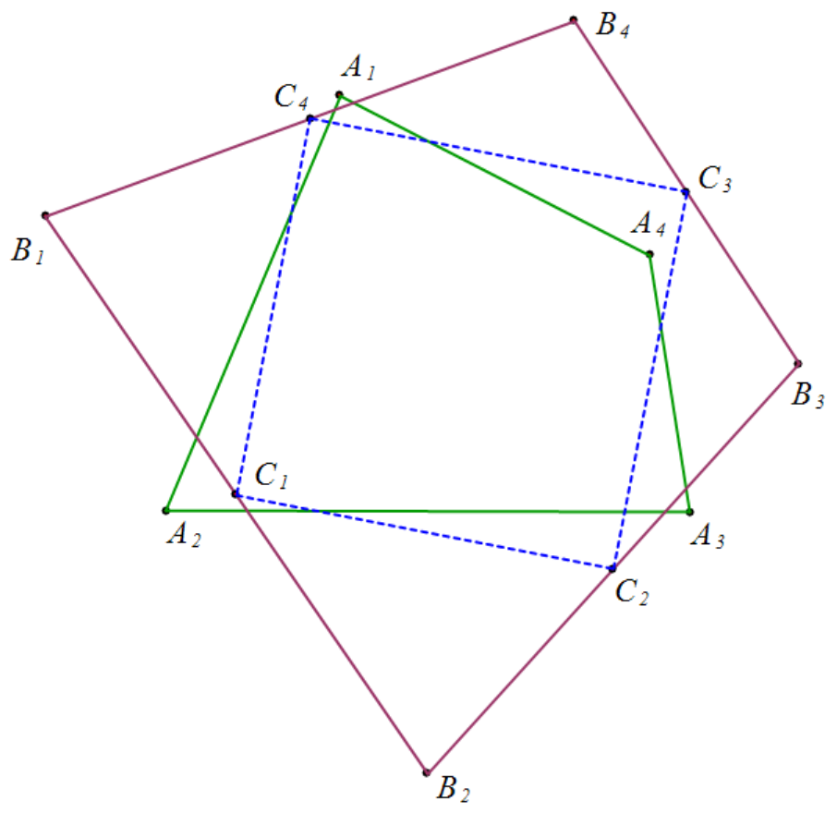

prove:

.

**Example 1: In quadrilaterals** , , , , are the midpoints of , , , respectively . Draw isosceles right angles , , , , . Prove that the quadrilateral is a square.

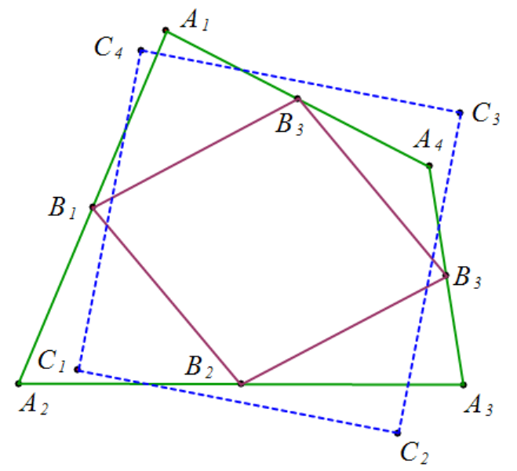



.

Note: In this example and the previous one, whether you make the isosceles right triangle first or the midpoint first does not affect the conclusion.

This is a special case of the Douglas - Newman theorem .

**Example 1:** The centers of squares ABED, BHIC and ACFG are J, K and L respectively. Prove that: and .

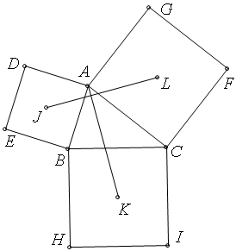

prove: .

**Example 1:** Draw △BPA∽△DRC from each side of quadrilateral ABCD. F, G, and I are the midpoints of AC, BD, and PR respectively. Prove that △ GIF∽ △DRC.

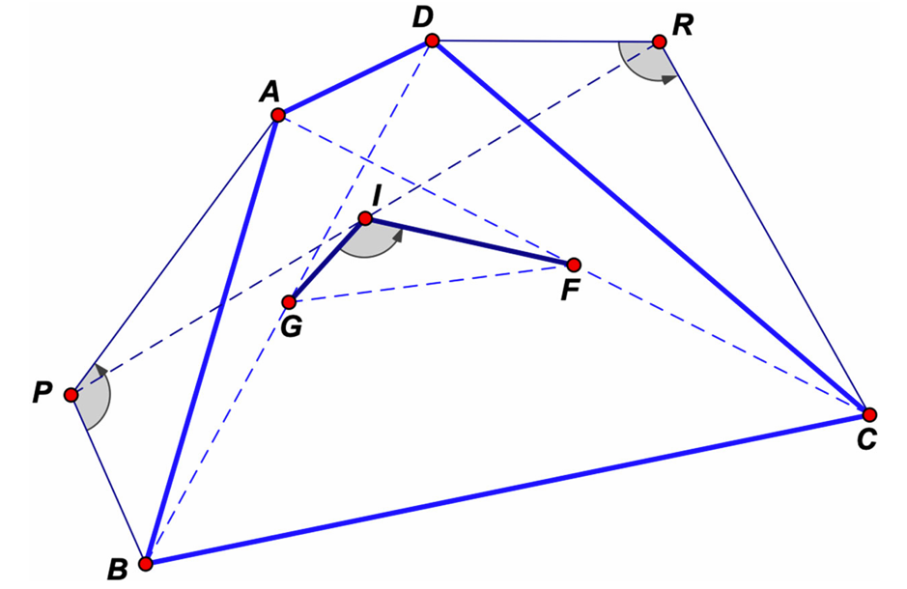

prove:

.

**Example 1 : Given six numbers** **, if any five of them are similar in sequence , then** the sixth one is also similar in sequence.

prove:

.

Note: It is easy to generate identities, and based on the identities, it is easy to generate theorems.

**Example 1 :** O is the center of regular hexagon ABCDEF, X and Y are the midpoints of AB and DF respectively. Prove that: △OAB ∽ △YXC.

Proof: Assume that , ,

.

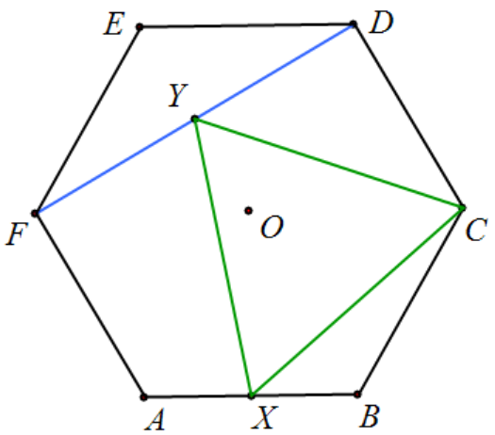

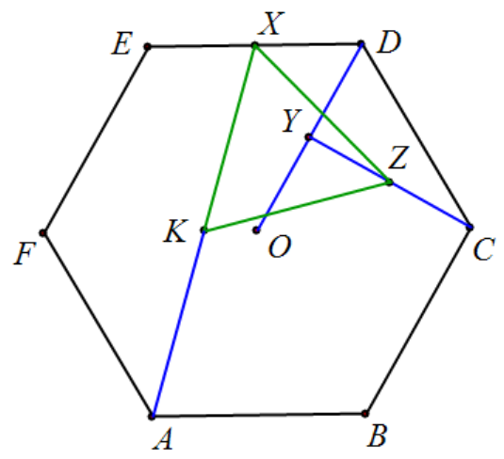

**Example 1 :** The center O of regular hexagon ABCDEF, X, Y, Z, K are the midpoints of DE, OD, CY, AX respectively. Prove that: △OAB ∽ △XKZ.

Proof: Let , , ,

.

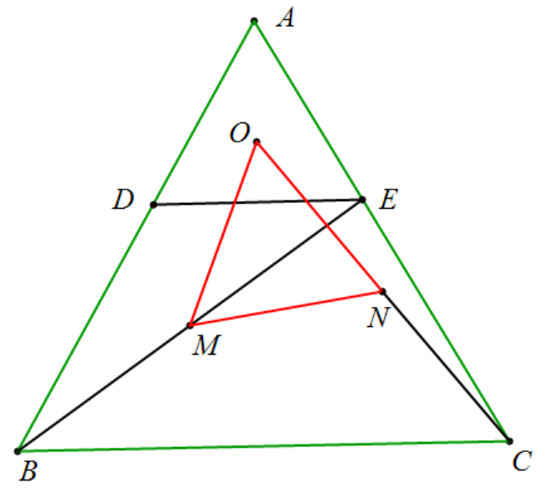

**Example 1 :** In an equilateral triangle ABC, D and E are on AB and AC respectively, DE∥BC, O is the centroid of △ADE, M is the midpoint of BE, and N is the midpoint of CO. Prove that △OMN is an equilateral triangle.

prove: , , ,

.

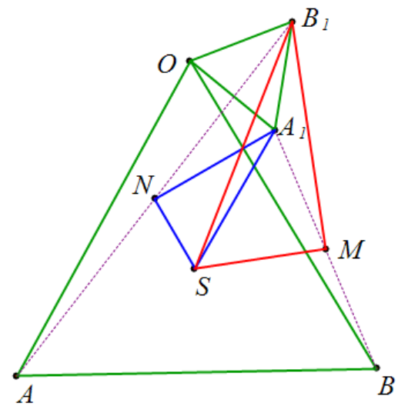

**Example 1:** Given equilateral triangles OAB and S, S is the centroid of △OAB, and M and N are the midpoints of and respectively . Prove: .

Proof: According to the identity, △ SMB' and △SNA' are similar to triangles with an angle of 30°-60°-90°.

, .

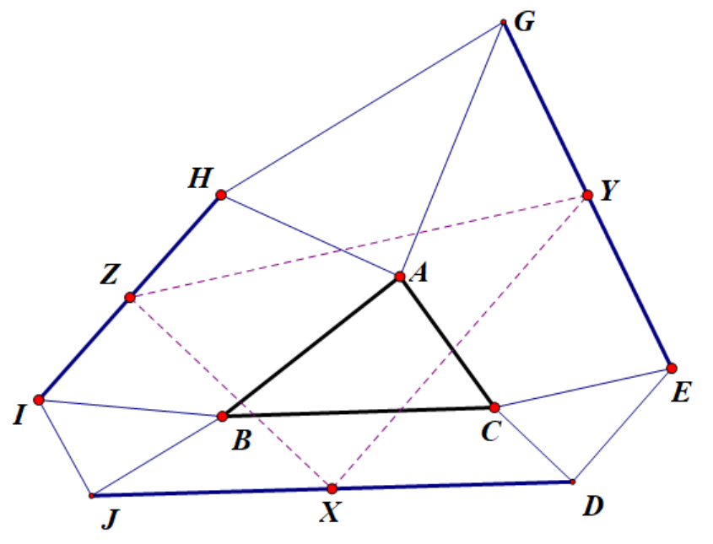

**Example 1:** As shown in the figure, it is known that △DEC∽△AGH∽△JBI∽△ABC, X is the midpoint of JD, Y is the midpoint of EG, and Z is the midpoint of HI. Prove that: △XYZ∽△ABC.

prove: .

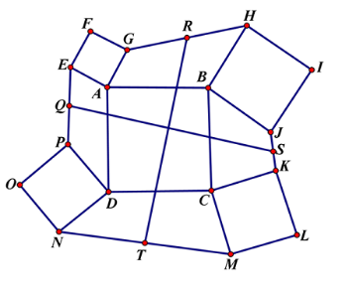 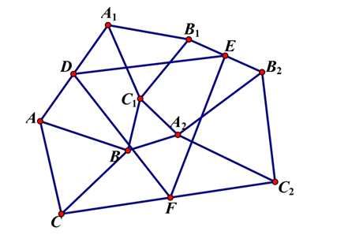

**Example 1:** Quadrilaterals ABCD, AEFG, BHU, CKLM, and DNOP are all squares. Q , R, S, and T are the midpoints of PE, GH, JK, and MN, respectively. Prove that QS ⊥ RT and QS =RT.

prove:



 .

**Example 1:** Construct △ EAB ∽ △ FCB ∽ △ GCD ∽ △ HAD around quadrilateral ABCD , then EFGH is a parallelogram. Let the midpoints of diagonals AC and BD be N and M respectively , and the center of the parallelogram be O , then △ ONM ∽ △ EAB .



prove: .

set up , .

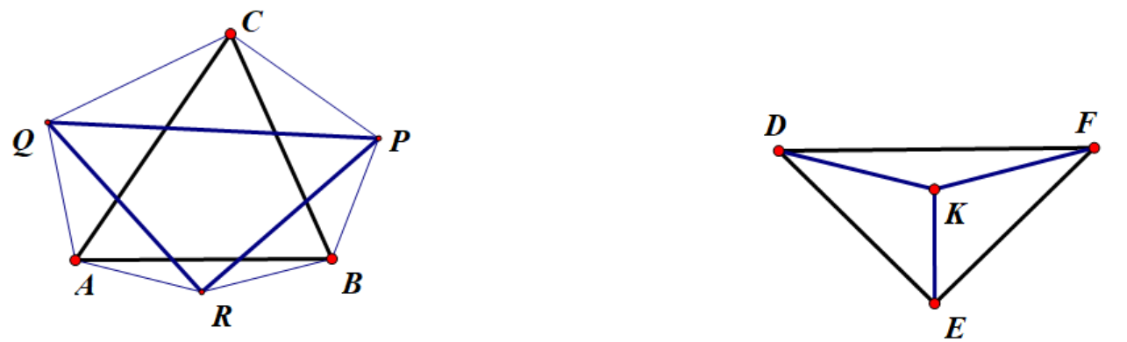

**Example 1:** As shown in the figure, construct △ABR, △BCP, and △CAQ outside the triangle △ABC, satisfying ∠PBC = ∠CAQ = 45 °, ∠BCP = ∠QCA = 30 °, and ∠ABR = ∠BAR = 15 °. Prove that: RP = RQ, and RP ⊥ RQ. ( 1975 IMO exam question)

prove: .

Construct △ *ABR* ∼ *DFK* , △ *BCP* ∼ *EDK* , and △ *CAQ* ∼ *FEK* . Using the complex number-determinant identity, we obtain △ *RPQ* ∼ *EFD* . Since *EF* = *ED* and *EF* ⊥ *ED* , we also obtain *RP* = *RQ* and *RP* ⊥ *RQ* . Feel free to try other angles as long as the triangles involved are similar. Experimentation has shown that this approach can be extended to quadrilaterals and even *n* -gons.

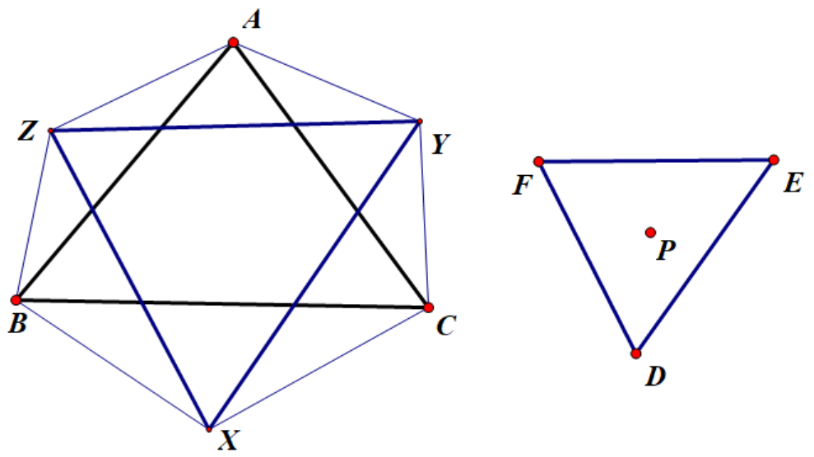

prove: .

As shown in the figure, construct △BXC∽FPE, △CYA∽DPF, △AZB∽FPD, then according to the determinant identity, we can get △XYZ∽DEF.

**Special case 1:** When P is the center of the equilateral △DEF, according to △XYZ∽△DEF, △XYZ is an equilateral triangle, which is Napoleon's theorem.

**Special case 2 :** When D, E, F, and P are collinear, then X, Y, and Z are on the straight lines BC, CA, and AB respectively. According to △XYZ∽△DEF, △XYZ degenerates into a straight line, which is Menelaos' theorem.

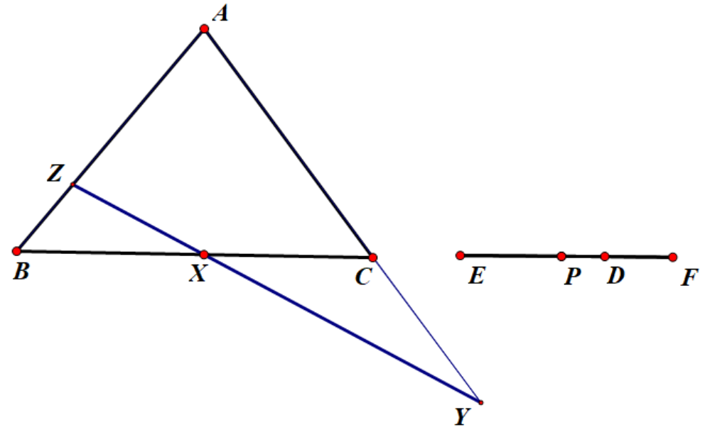

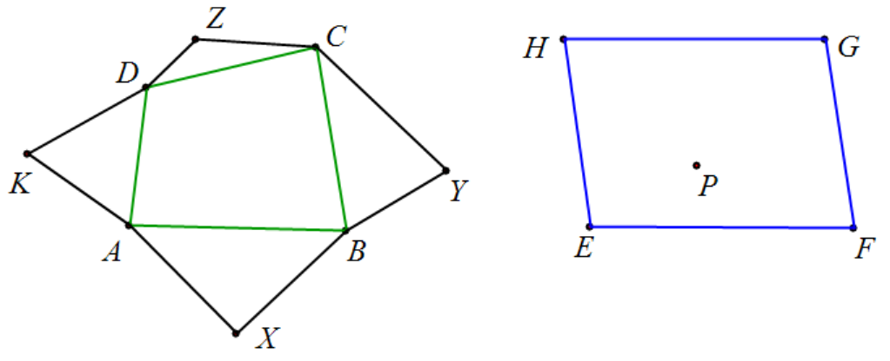

**Example 1:** As shown in the figure, quadrilateral ABCD, draw △ABX, △BCY, △CDZ, △DAK outside the shape , and there is also parallelogram EFGH. For any point P, if △ABX∽△HGP, △BCY∽△EHP, △CDZ∽△FEP, △DAX∽△GFP, draw parallelogram KXZS, then △SKY∽△HEF.

Proof: Assume , ,

.

Special case 1: When P is the center of the square HEFG, then △ABX, △BCY, △CDZ, and △DAK are all isosceles right triangles. This is Obert's theorem, KY is perpendicular and equal to XZ.

Special case 2 : When P is the center of rectangle HEFG, △HEP is an equilateral triangle, EF⊥EH, △ABX and △CDZ are isosceles triangles with vertex angles of 120 ° , △BCY and △DAK are equilateral triangles, so KY⊥XZ .

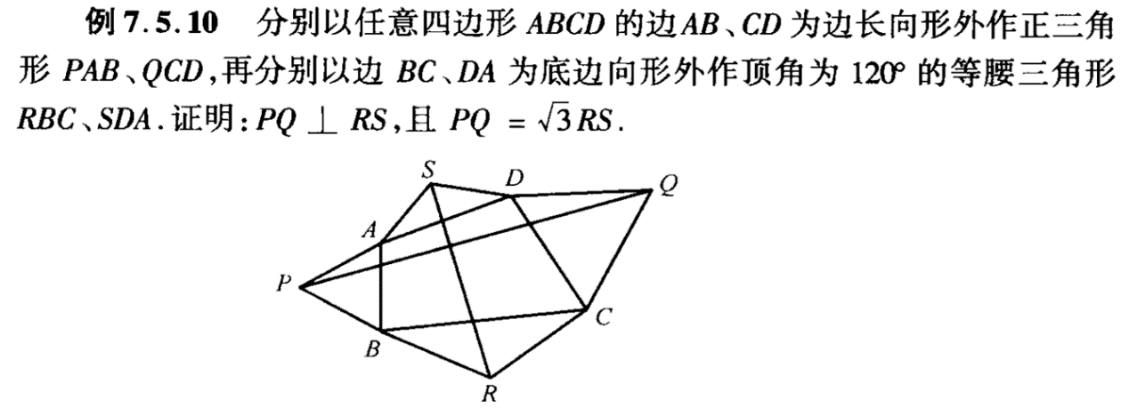

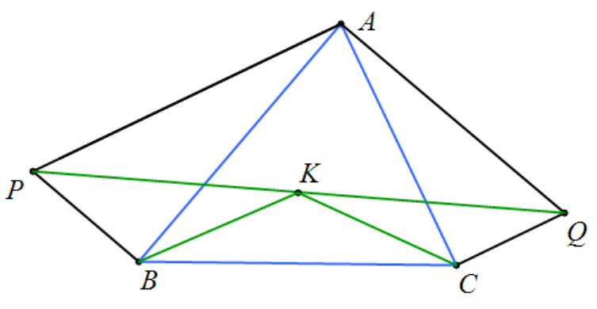

**Example 1:** Construct △ABP and △ACQ outside the triangle ABC, ∠ABP=ACQ= 90 °, ∠PAB=QAC , K is the midpoint of PQ, prove that: ∠KBC=∠KCB=∠PAB.

prove: .

**Example 1:** Construct △ABP and △ACQ outside the triangle ABC, ∠APB=AQC= 90 °, ∠PAB=QAC , K is the midpoint of BC, prove that: ∠KPQ=∠KQP=∠PAB.

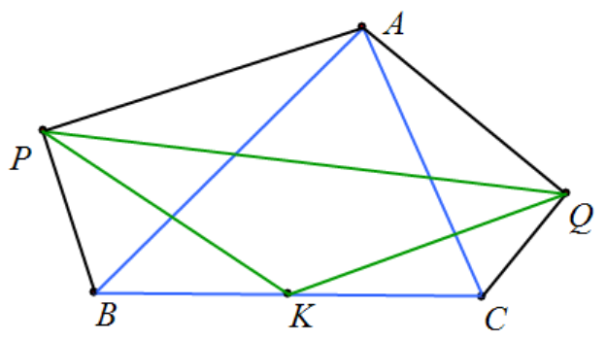

prove: .

**Example 1: In quadrilateral ABCD, there is point O** , OA = 0 D, OB = 0 C, and ∠ AO D = ∠BO C = 120 ° . Points E , F , and G are the midpoints of line segments BC , CD , and DA respectively . Prove that △ KML is an equilateral triangle.

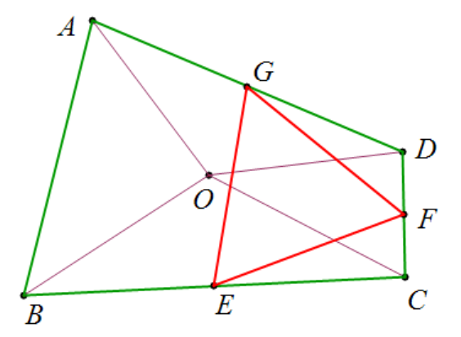

prove:

or .

**Example 1: As shown in the figure, there is point O in quadrilateral ABCD** , OA =0 D , OB =O C , and ∠AO D = ∠BO C =120 ° . If △ABK is an equilateral triangle, prove that △CDK is an equilateral triangle. (Training questions for the 2004 Chinese National Training Team)

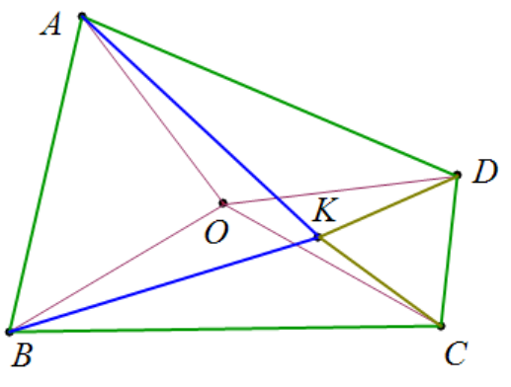

prove: .

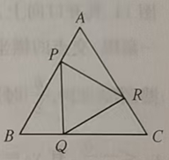

**Example 1:** In equilateral triangle ABC, P, Q, and R are on AB, BC, and CA respectively, and PQ ⊥ BC , QR ⊥ AC, and RP ⊥ AB. Prove that △PQR is an equilateral triangle .

prove:

.

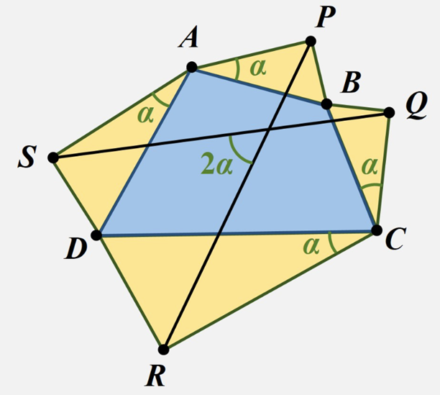

**Example 1: For quadrilateral ABCD, construct a right angle** △ APB on side AB , with the right angle at P. Similarly, for the other sides, construct right triangles BQC , CRD, and DSA, such that ∠PAB = ∠SAD = ∠RCD = ∠QCB. Prove that: PR = QS , and the angle between PR and QS is twice ∠PAB . (Van Oberle's theorem for right triangles)

prove:

**Inverse Similarity**

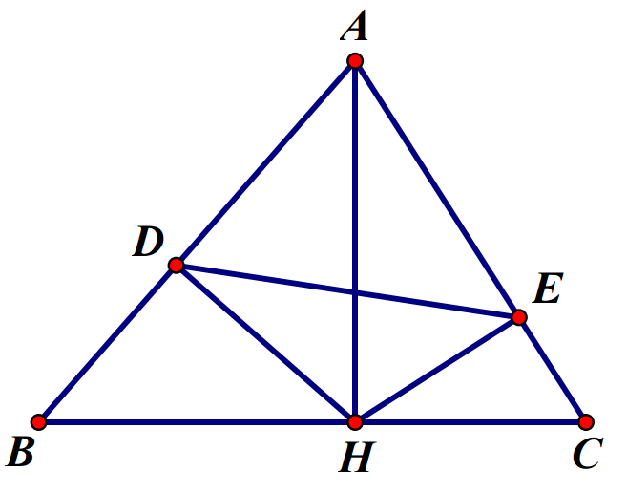

**Example 1: As shown in the figure, in triangle ABC, AH is the height on side BC. Through H, draw HD ⊥ AB at D, and draw HE ⊥ AC at E. Prove: △ ABC ∽ △AED** .

prove: .

**Example 15: As shown in Figure 15,** there is a point P inside △ABC, which satisfies ∠CAP=∠CBP. M and L are the feet of the perpendiculars from P to the sides CA and CB respectively. D is the midpoint of AB. Prove that: DM=DL.

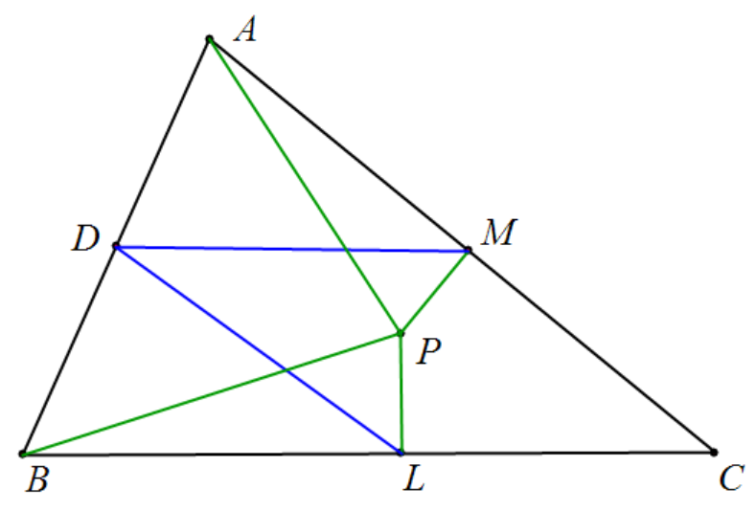

Proof 1: Suppose , , , suppose , then , similarly , , then .

Proof 2 : .

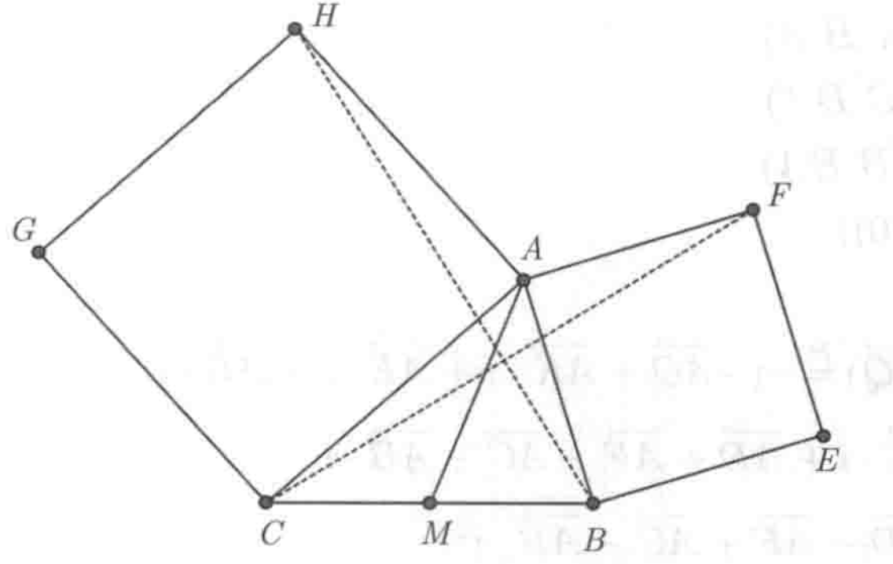

**Example 1: On sides AB and AC of** triangle ABC, construct two squares ABEF and ACGH . Prove that FC ⊥ BH and FC=BH.

prove: .

**Example 1:** is a point on the side of or its extension line. If there are three points such that and , and are directly similar, prove that: the three points are collinear, and .

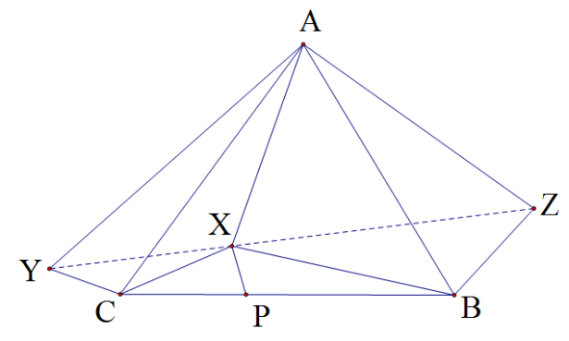

**Figure 12**

prove:





**Extension: If** and , and are exactly similar respectively, prove: and are exactly similar.

**Example 1:** Suppose hexagon ABCDEF has a center of symmetry O , and quadrilateral ABCO is a parallelogram. Construct an equilateral triangle outward from each side of the hexagon . Then, denote the third vertices of the six constructed equilateral triangles as M, N, P, Q, R, and S. Prove: Hexagon MNPQRS is a regular hexagon.

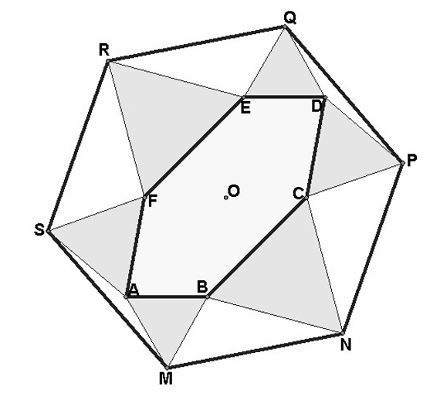

It is only proved that when △ABM and △CBM are equilateral triangles, △OMN is an equilateral triangle.

prove: .

Note: Based on the identity equation, it is also possible to change outward to inward.

**Example 1:** Given an equilateral triangle ABC with D as a point inside, construct isosceles triangles BDE and CDF with B and C as vertices and BD and CD as legs , with vertex angles of 120°. Connect AE and AF and prove that AE=AF, ∠EAF =120 °.

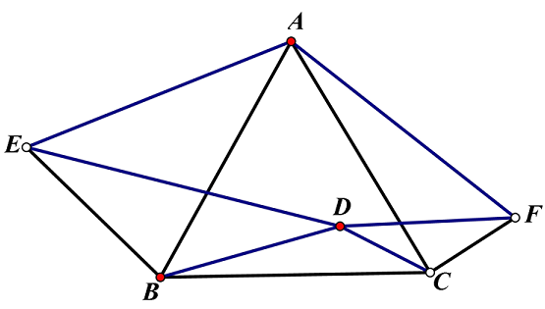

prove: .

**Example 1:** Given an equilateral side , with and as two internal points, draw an isosceles triangle with and as vertices and and as legs , with vertex angles and . Connect and and to make an isosceles triangle such that and . Connect and . Prove that: , .

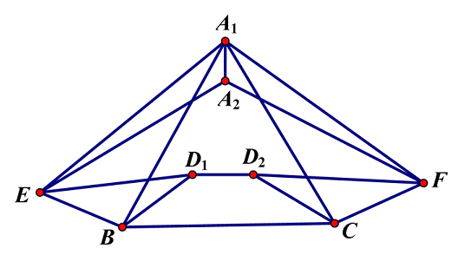

prove: .

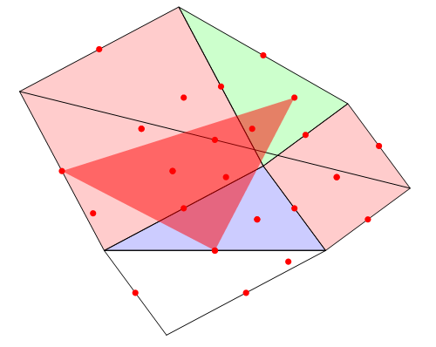 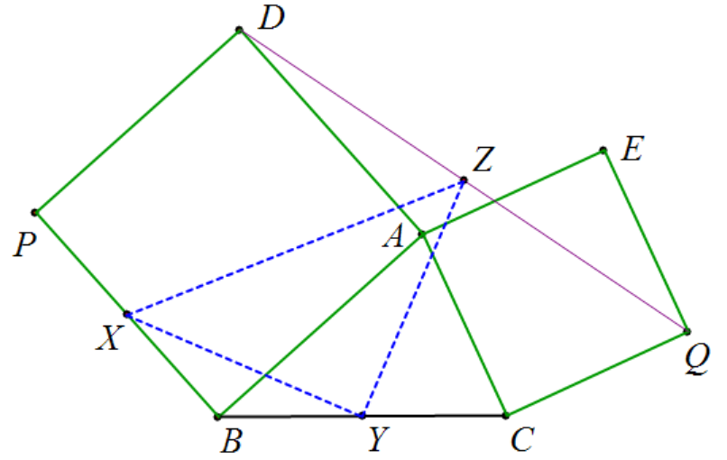

**Example 1:** From the two sides AB and AC of triangle ABC, construct squares BADP and CAEQ respectively. X, Y, and Z are the midpoints of BP, BC, and DQ respectively. Prove that: △XYZ is an isosceles right triangle.

prove: .

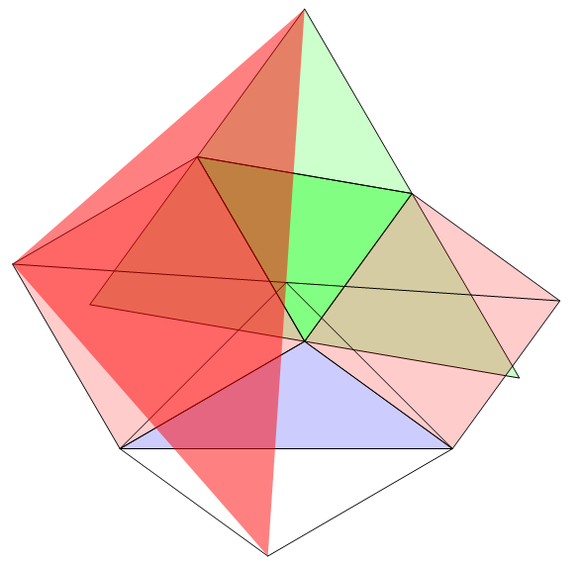 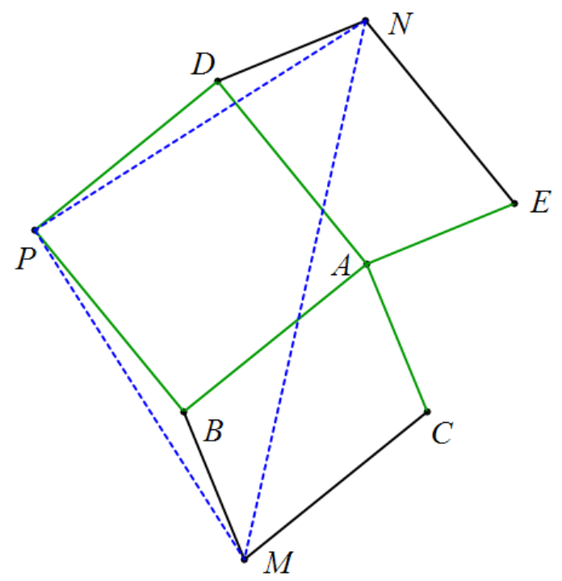

**Example 1:** Given square BADP, parallelograms ABMC and AEND, prove that △PMN is an isosceles right triangle.

prove: .

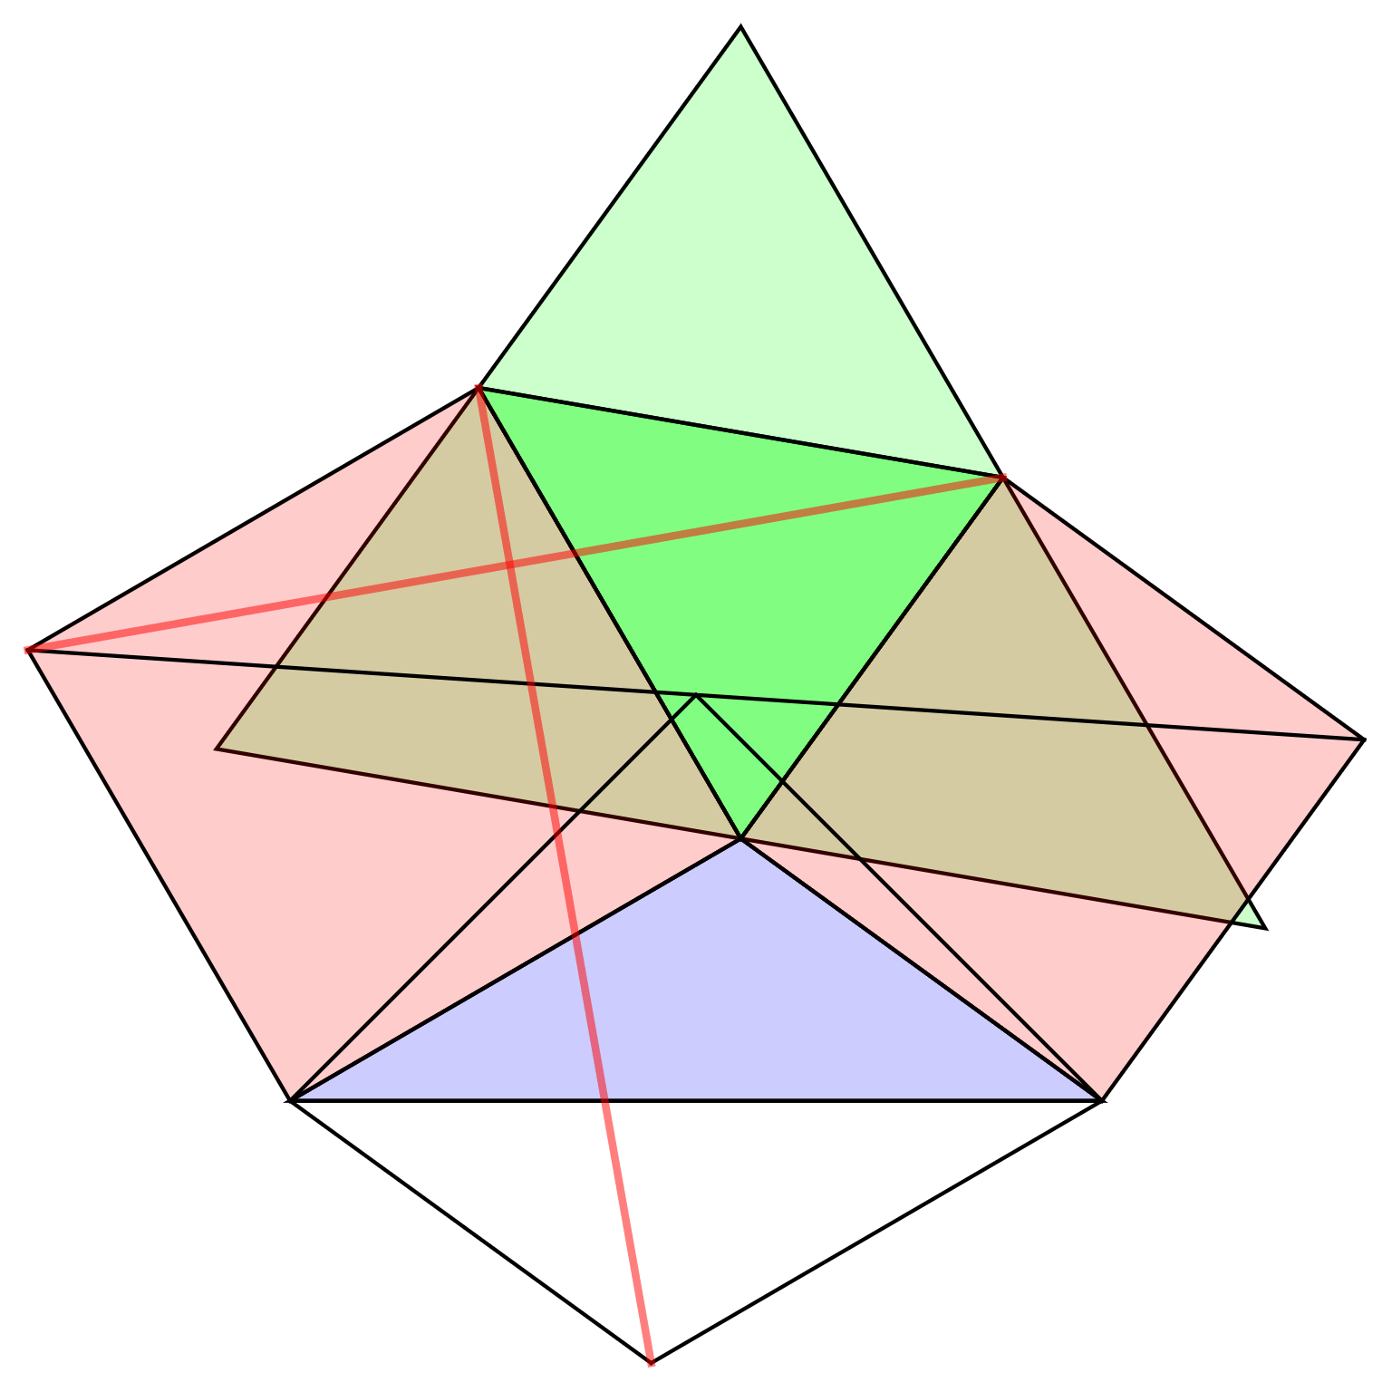 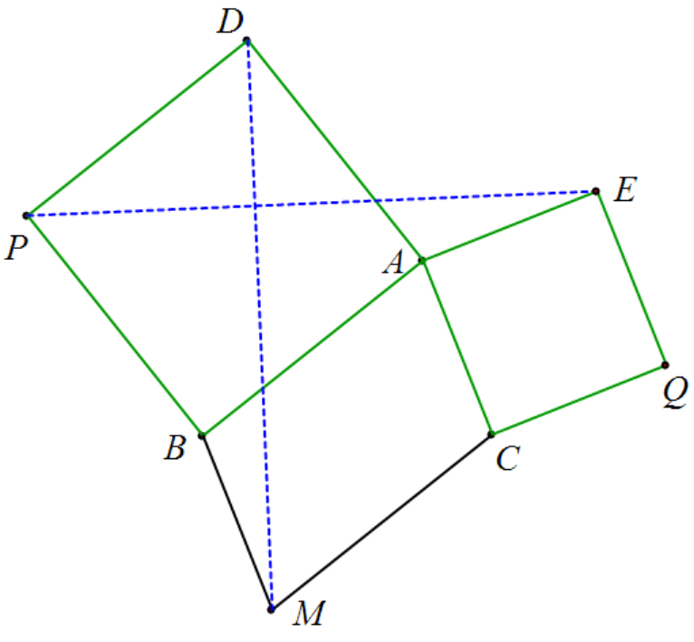

**Example 1:** Given squares BADP, CAEQ, and parallelogram ABMC, prove that: PE⊥MD, PE=MD.

prove: .

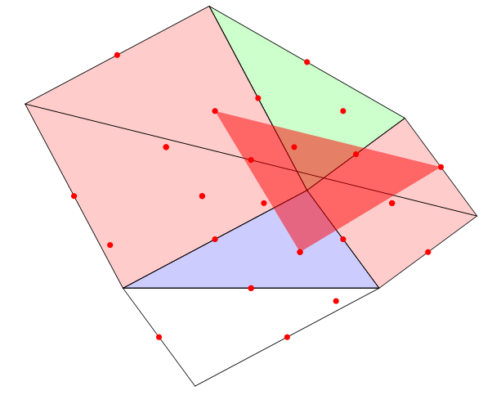 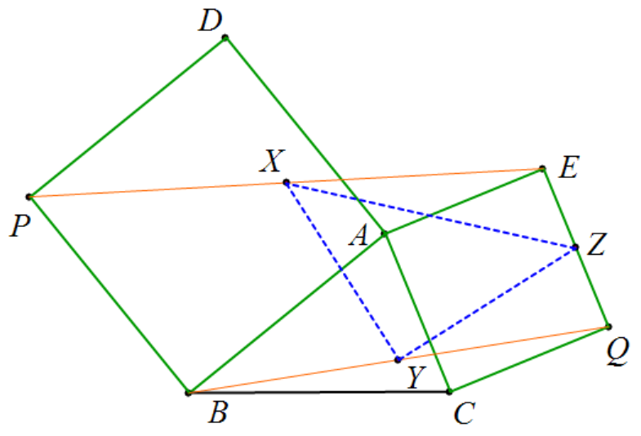

**Example 1:** Given squares BADP and CAEQ, and X, Y, and Z being the midpoints of PE, BQ, and EQ respectively, prove that △XYZ is an isosceles right triangle.

prove: .

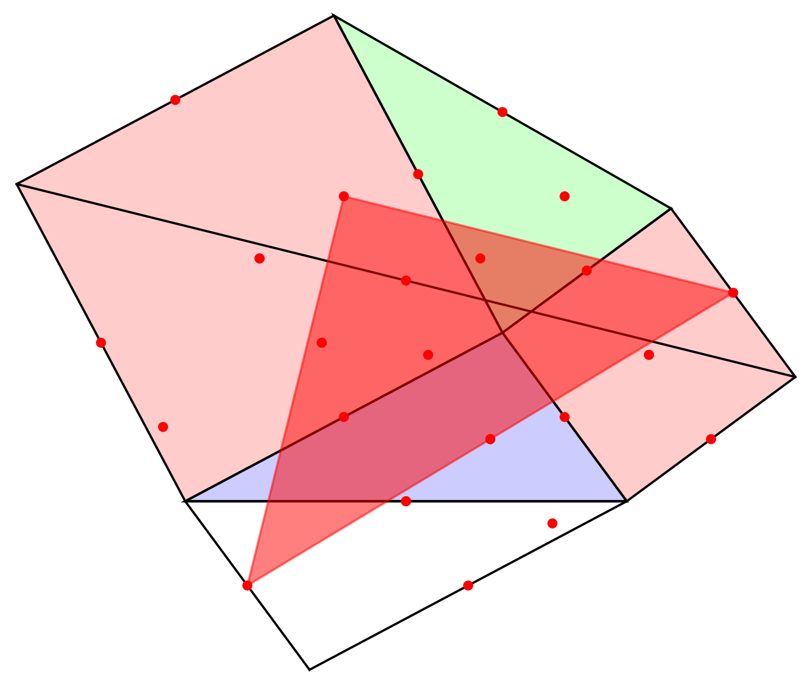 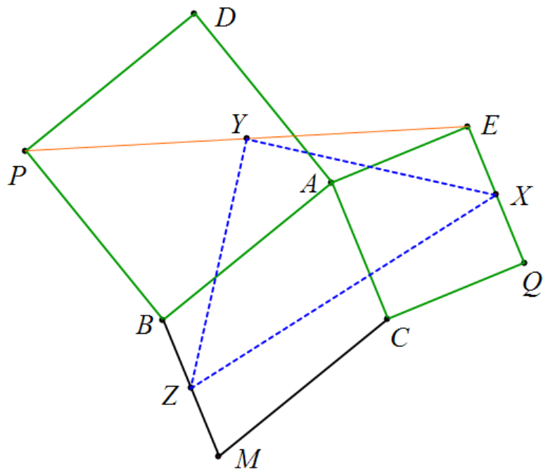

**Example 1:** Given squares BADP and CAEQ, and X, Y, and Z being the midpoints of PE, BQ, and EQ respectively, prove that △XYZ is an isosceles right triangle.

prove: .

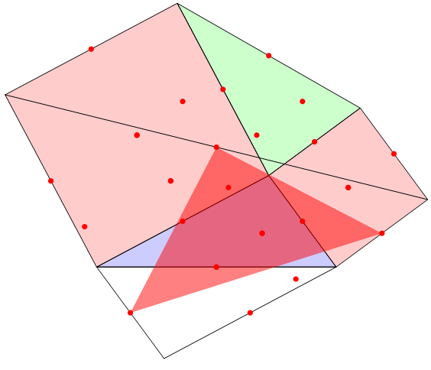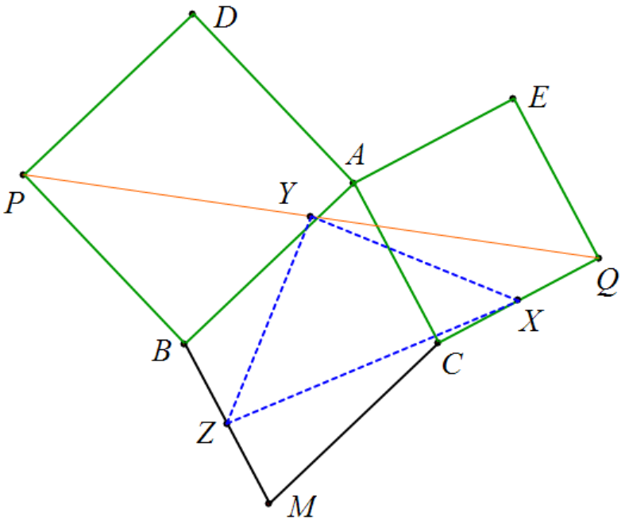

**Example 1:** Given squares BADP and CAEQ, and parallelogram CABM, with X, Y, and Z being the midpoints of CQ, PQ, and BM respectively, prove that △XYZ is an isosceles right triangle .

prove: .

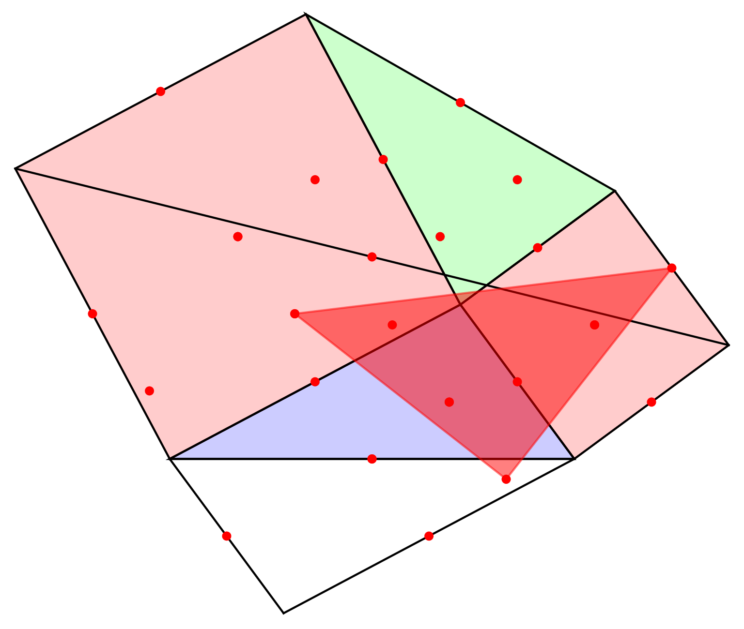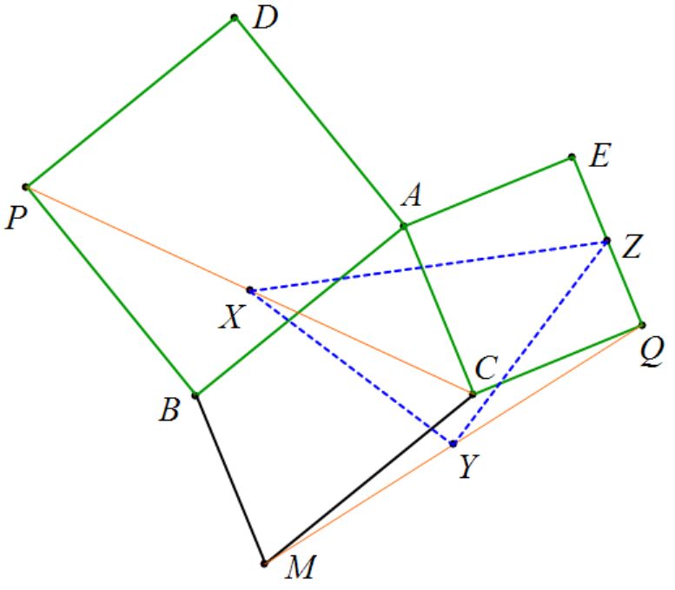

**Example 1:** Given squares BADP and CAEQ, and parallelogram CABM, and X, Y, and Z being the midpoints of CP, MQ, and EQ respectively, prove that △XYZ is an isosceles right triangle.

prove: .

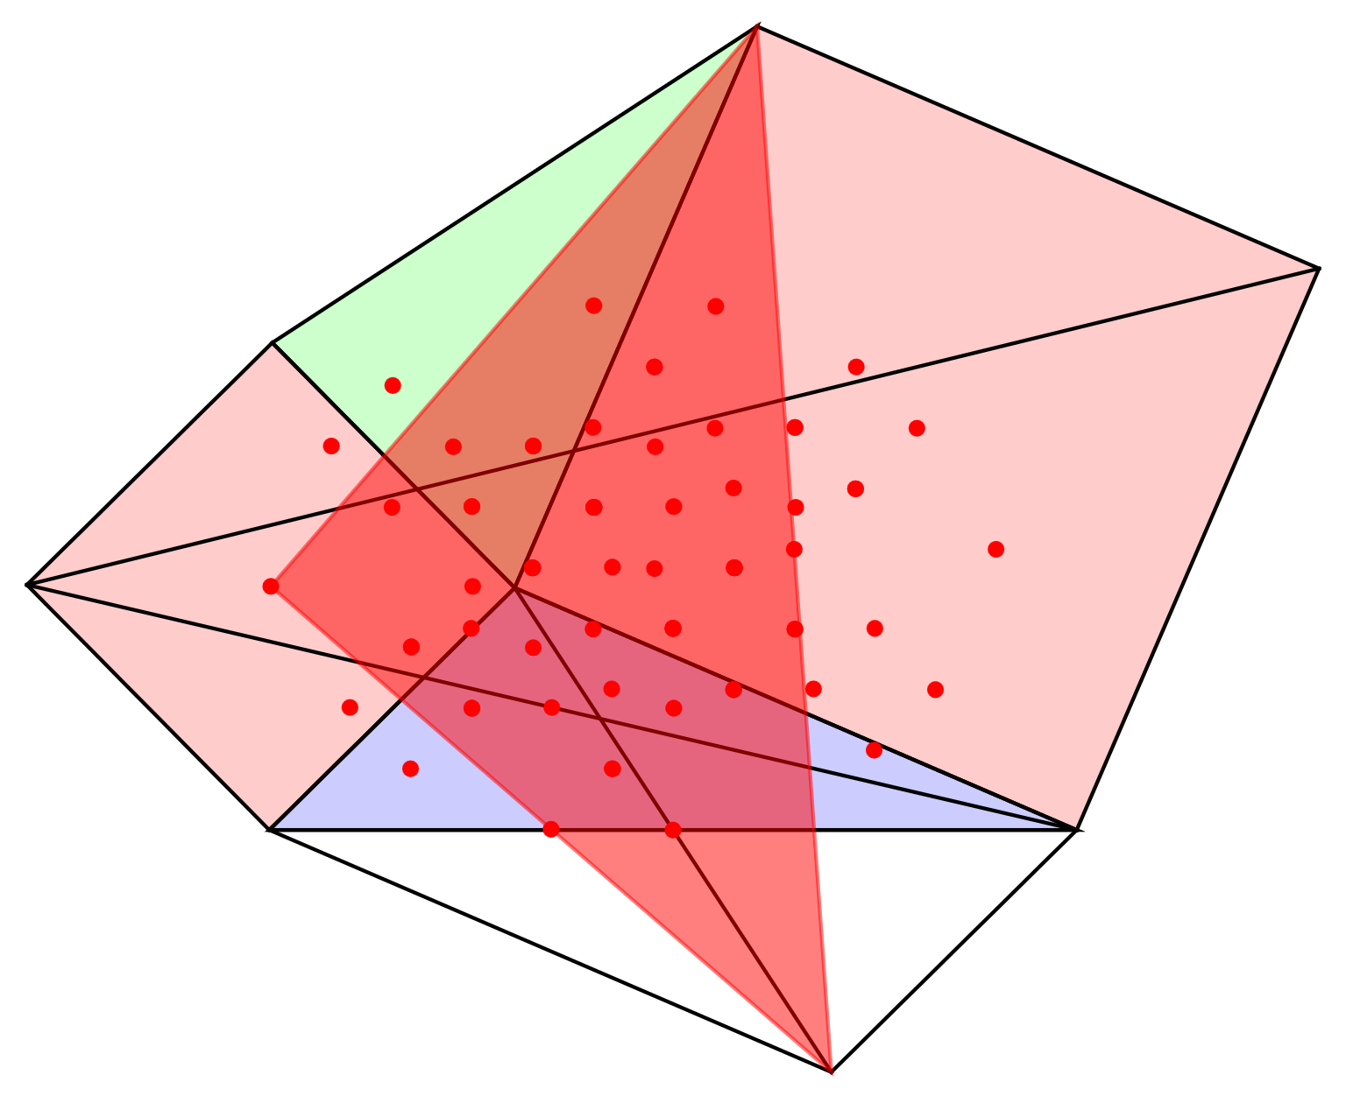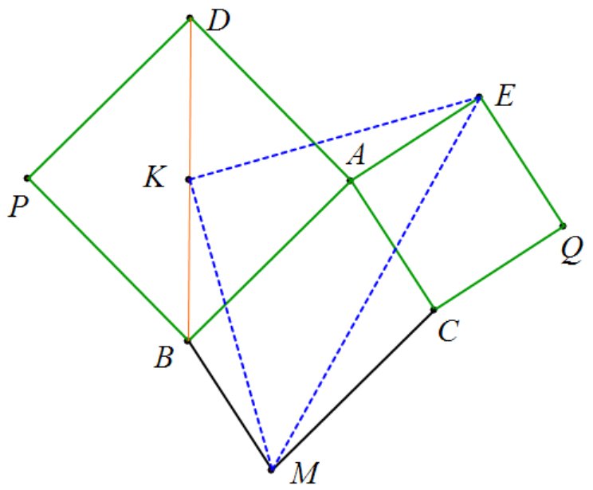

**Example 1:** Given squares BADP and CAEQ, parallelogram CABM, and K is the midpoint of BD, prove that △EKM is an isosceles right triangle.

prove: .

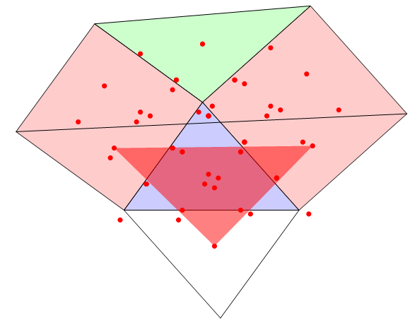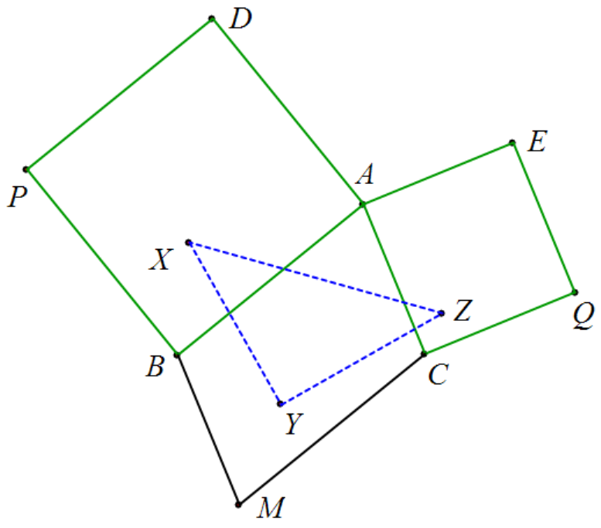

**Example 1:** Given squares BADP and CAEQ, and parallelogram CABM, and X, Y, and Z being the centroids of △ABP, △MBC, and △MQE respectively, prove that △XYZ is an isosceles right triangle.

prove: .

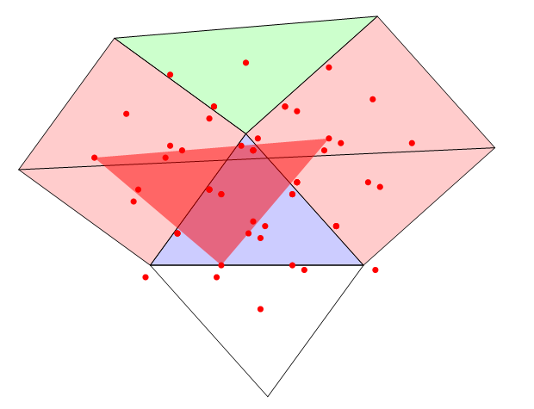 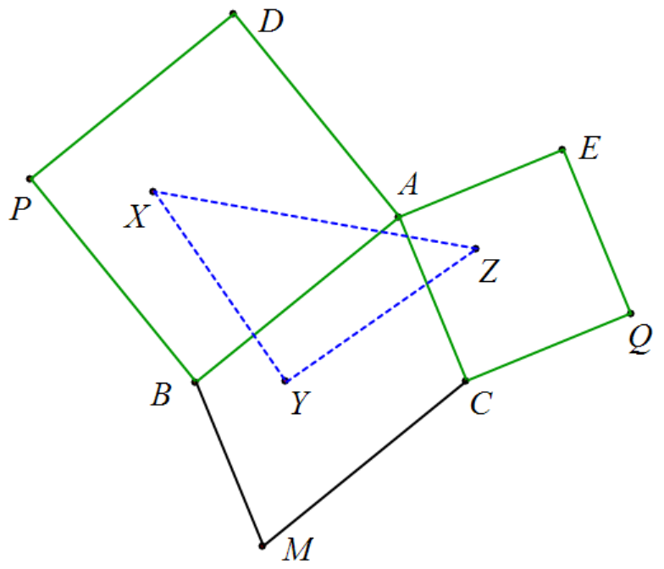

**Example 1:** Given squares BADP and CAEQ, and parallelogram CABM, and X, Y, and Z being the centroids of △BDP, △BMA, and △ACE respectively, prove that △XYZ is an isosceles right triangle.

prove:



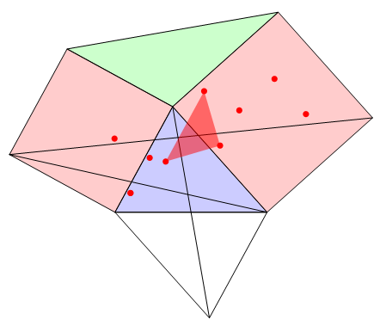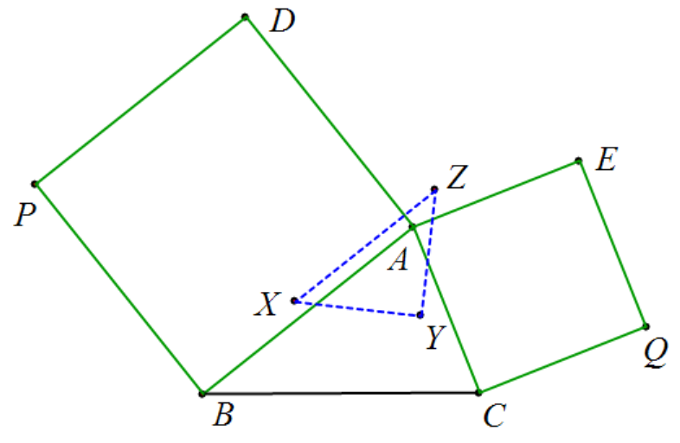

**Example 1:** Given squares BADP and CAEQ, parallelogram CABM, and X, Y, and Z as the centroids of △PQB, △QBA, and △CDE respectively, prove that △XYZ is an isosceles right triangle.

prove: .

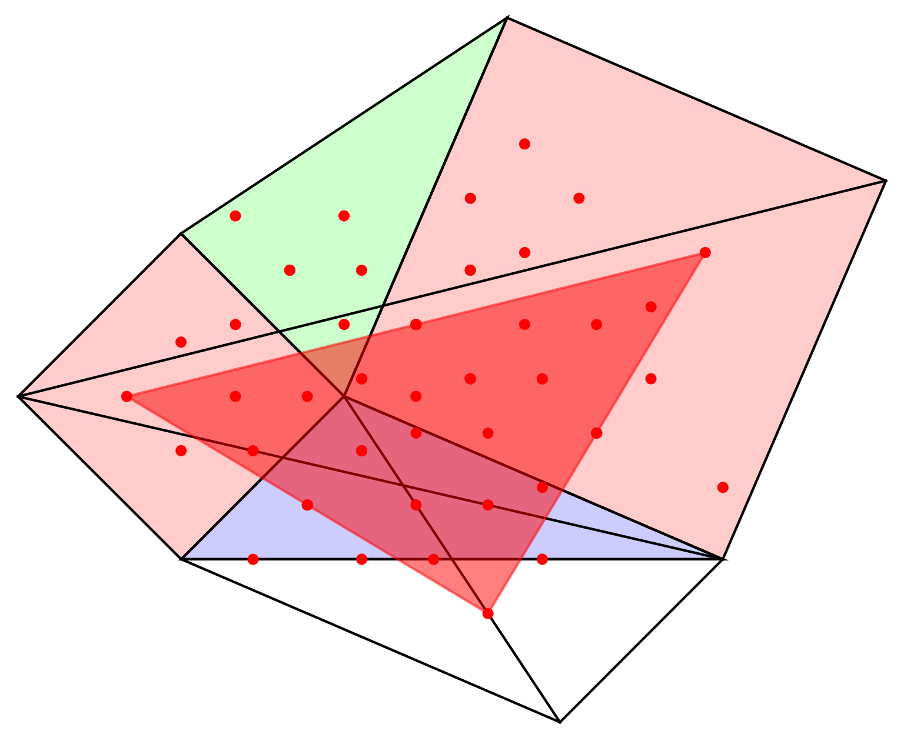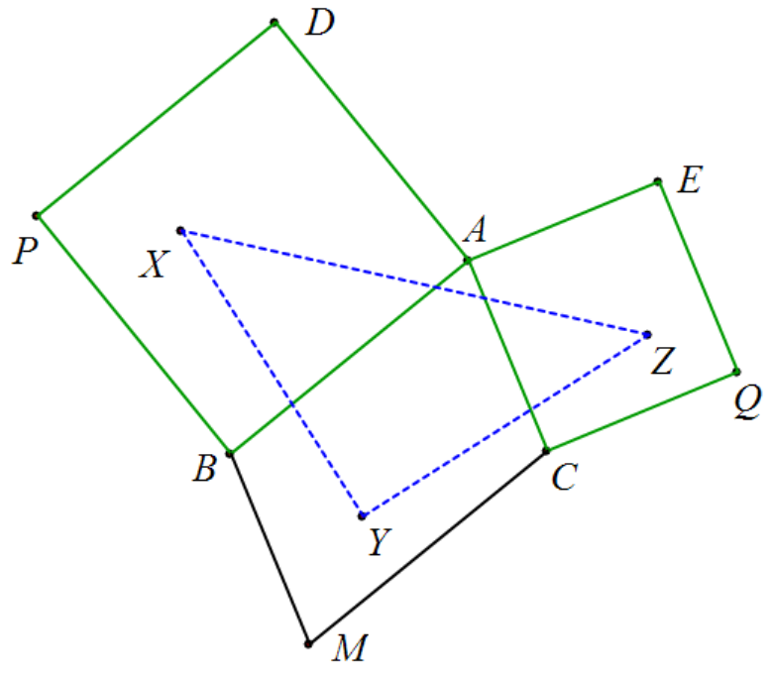

**Example 1:** Given squares BADP and CAEQ, parallelogram CABM, and X, Y, and Z as the centroids of △PQB, △QBA, and △CDE respectively, prove that △XYZ is an isosceles right triangle.

prove: .

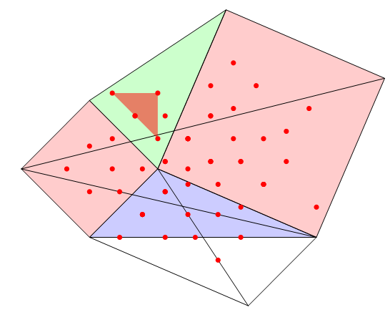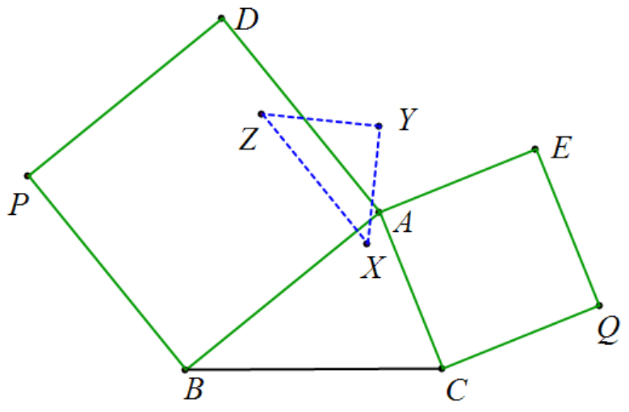

**Example 1:** Given squares BADP and CAEQ, parallelogram CABM, and X, Y, and Z as the centroids of △ABE, △DE, and △PDE respectively, prove that △XYZ is an isosceles right triangle.

prove: .

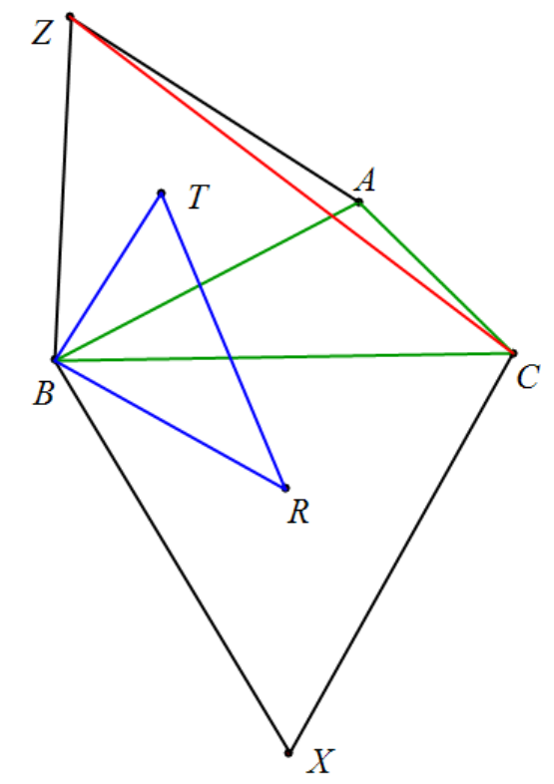

**Example 1:** Construct equilateral triangles △CBX and △AZB outside △ABC. R and T are the centroids of △CBX and △AZB respectively. Prove that: △ RBT ∽△ CBZ .

prove: .

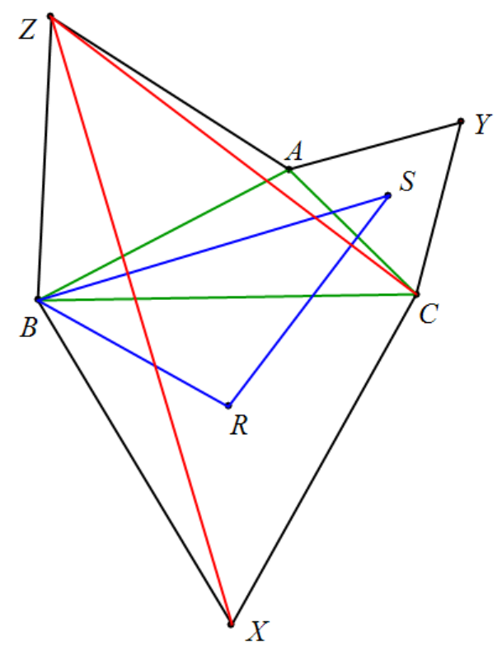

**Example 1:** Construct equilateral triangles △CBX, △YAC, and △AZB outside △ABC. R, S, and T are the centroids of △CBX, △YAC, and △AZB respectively. Prove that: △ SBR ∽△ ZXC .

prove: .

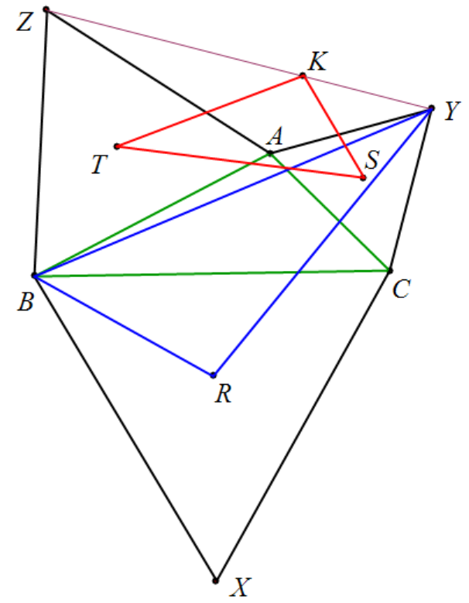

**Example 1:** Construct equilateral triangles △CBX, △YAC, and △AZB outside △ABC. R, S, and T are the centroids of △CBX, △YAC, and △AZB respectively. K is the point that divides YZ into three equal parts. 3YK = YZ. Prove that: △TS K ∽△YBR.

prove:

.

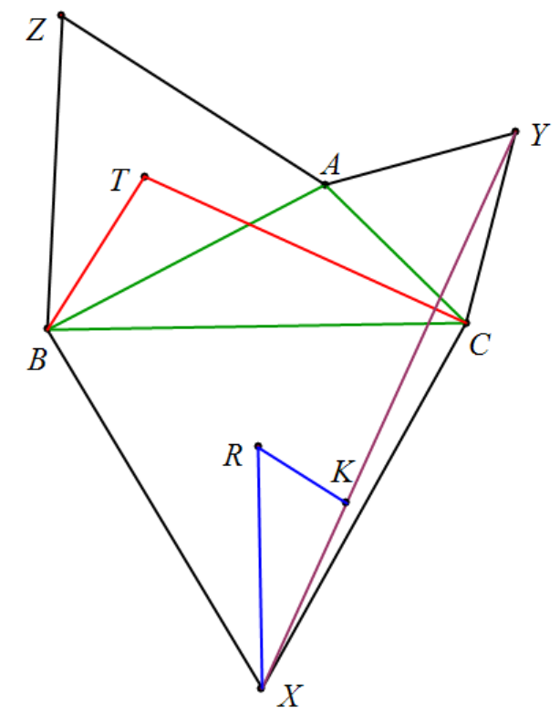

**Example 1:** Construct equilateral triangles △CBX, △YAC, and △AZB outside △ABC. R, S, and T are the centroids of △CBX, △YAC, and △AZB respectively. K is the point that divides XY into three equal parts. 3XK = XY. Prove that △ XKR ∽△ CTB .

prove: .

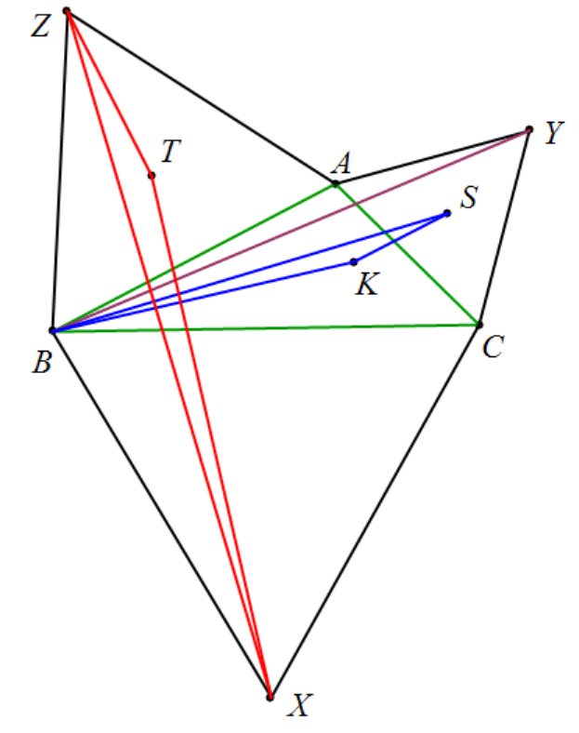

**Example 1:** Construct equilateral triangles △CBX, △YAC, and △AZB outside △ABC. K, S, and T are the centroids of △CBY, △YAC, and △AZB respectively. Prove that: △ BSK ∽△ XZT .

prove: .

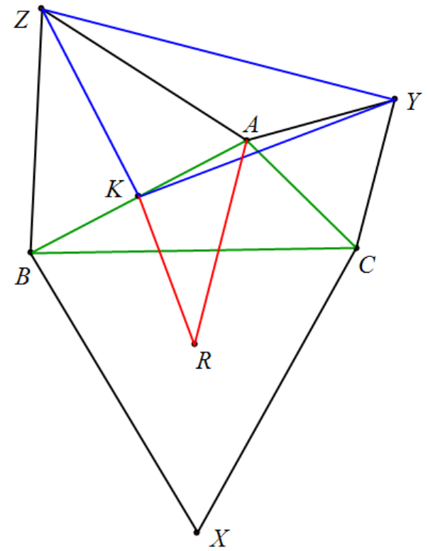

**Example 1:** Construct equilateral triangles △CBX, △YAC, and △AZB outside △ABC. R, S, and T are the centroids of △CBX, △YAC, and △AZB respectively. Prove that △ RAK ∽△ YZK .

prove: .

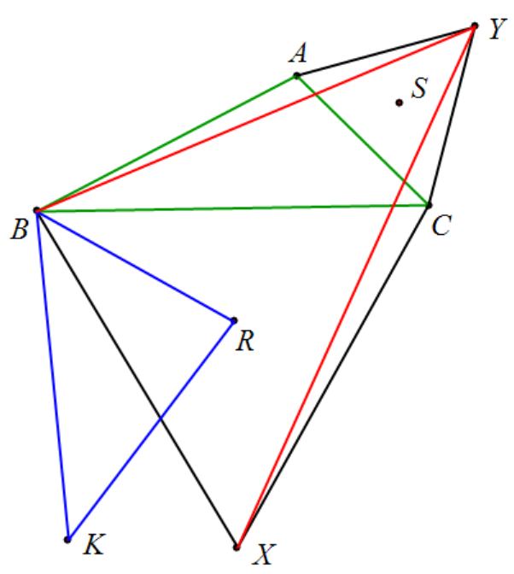

**Example 1: Draw** equilateral triangles △CBX and △YAC outside △ABC. R and S are the centroids of △CBX and △YAC respectively. K and S are symmetric about R. Prove that: △ KBR ∽△ YXB .

prove: .

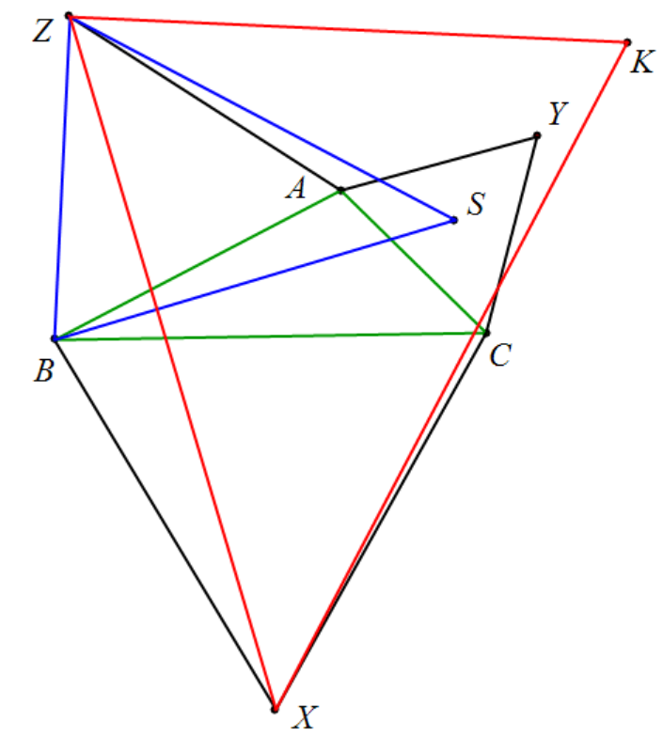

**Example 1:** Construct equilateral triangles △CBX, △YAC, and △AZB outside △ABC. S is the centroid of △YAC, and K and B are symmetric about A. Prove that △ ZSB ∽△ KXZ .

prove: .

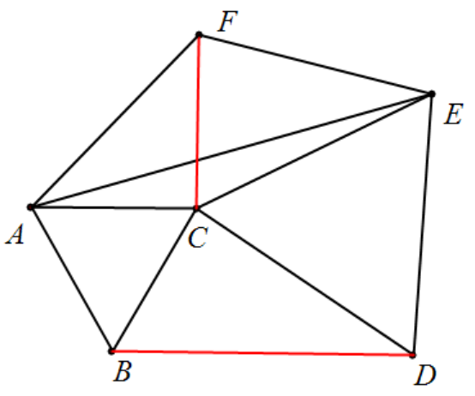

**Example 1: △ABC and △CDE are equilateral triangles, FA = FE, and ∠AFE = 120 °** . Proof: FC⊥BD.

prove: .

Note: According to the identity, FC⊥BD, and .

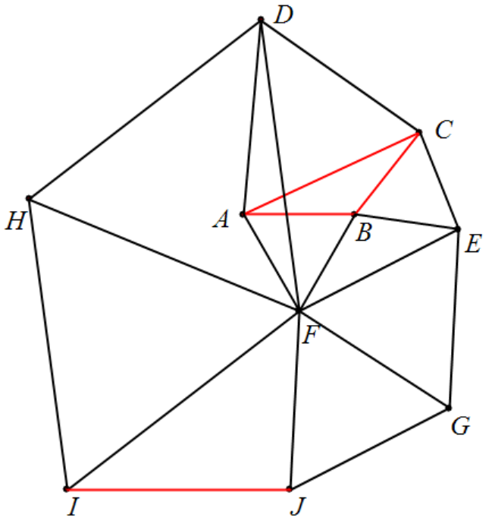

**Example 1: Starting from △ABC, draw equilateral △ACD, △CBE, △BAF, △EFG, △FDH, △FHI, △GFJ.** Prove that: AB∥IJ, 2AB=IJ.

prove:

.

Note: Use the same method to prove .

